Unit 5 – Waves: Quiz 2a

/5

- A double slit is illuminated with monochromatic light of wavelength 6.00 × 10² nm. The m = 0 and m = 1 bright fringes are separated by 3.0 cm on a screen which is located 4.0 m from the slits. What is the separation between the slits?

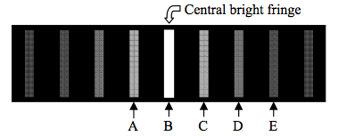
Use the image above to answer the next two questions:

- Which fringe is the same distance from both slits?
A, B, C, D, or E

- Which one of the following phenomena would be observed if the wavelength of light were increased?
- The fringes would be brighter.
- More bright fringes would appear on the screen.
- The distance between dark fringes would decrease.
- Single-slit diffraction effects would become non-negligible.
- The separation between bright fringes would increase.

Answers:

- Which fringe is the same distance from both slits?
A, B, C, D, or E

- Which one of the following phenomena would be observed if the wavelength of light were increased?
- The fringes would be brighter.
- More bright fringes would appear on the screen.
- The distance between dark fringes would decrease.
- Single-slit diffraction effects would become non-negligible.
- The separation between bright fringes would increase.

