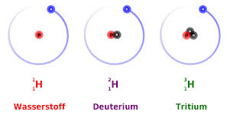

Consider the following nuclear fusion reaction that uses deuterium as fuel.



(a) Determine the mass defect of a single reaction, given the following information.

   

(b) Determine the energy in joules released during a single fusion reaction. (1 u = 1.66 x 10-27 kg)

(c) The United States requires about 1.0 x1020 J per year to meet its energy needs. How many deuterium atoms would be necessary to provide this magnitude of energy?

(d) Assume that 0.015% of the hydrogen atoms in seawater (H2O) are deuterium. The atomic mass number of oxygen is 16.00. About how many kilograms of seawater would be needed per year to provide the hydrogen fuel for fusion reactors to meet the energy needs of the United States?