Solutions Chem:

/5
Shapes of Molecules (BEG): Quiz 2b

Answer the following:

- H₂S
Electron Dot (Lewis) Structure
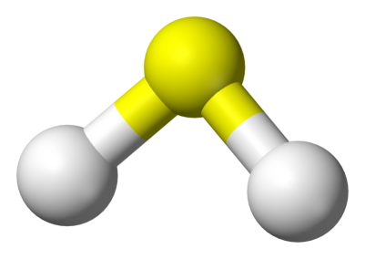

What is the geometry of this molecule? __________________________

Are the bonds Non-Polar, Polar, or Ionic? _______________________

- Complete the table below:

Molecule | 3D Structure | Bonding Pairs | Lone Pairs on Central Atom | Shape (name)
PF₅

Answers:

- H₂S
Electron Dot Structure
What is the geometry of this molecule? bent
Are the bonds Non-Polar, Polar, or Ionic? En = 0.4 ; Non-Polar

- Complete the table below: (1/2 mark each)

Molecule | 3D Structure | Bonding Pairs | Lone Pairs on Central Atom | Shape (name)
PF₅ | 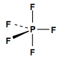 | 5 | 0 | Trigonal Bipyramidal

