Solutions Chem:
Shapes of Molecules (BEG): Quiz 2a

/5

Answer the following:

- PBr₃
Electron Dot (Lewis) Structure
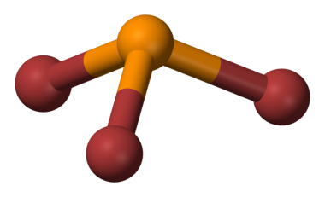

What is the geometry of this molecule? __________________________

Are the bonds Non-Polar, Polar, or Ionic? _______________________

- Complete the table below:

Molecule | 3D Structure | Bonding Pairs | Lone Pairs on Central Atom | Shape (name)
CH₄

Answers:

- PBr₃
Electron Dot (Lewis) Structure
What is the geometry of this molecule? trigonal pyramidal
Are the bonds Non-Polar, Polar, or Ionic? En = 0.7 ; Polar

- Complete the table below: (1/2 mark each)

Molecule | 3D Structure | Bonding Pairs | Lone Pairs on Central Atom | Shape (name)
CH₄ | 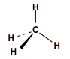 | 4 | 0 | Tetrahedral

