Worksheet 6.5 – Equipotential Lines and more Electric Potential!

- When +3.0 C of charge moves from point A to point B in an electric field, the potential energy is decreased by 27 J. It can be concluded that point B is:
  - 9.0 V lower in potential than point A.
  - 9.0 V higher in potential than point A.
  - 81 V higher in potential than point A.
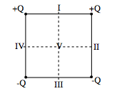
  - 81 V lower in potential than point A.

- Four charges are arranged on the four corners of a square as shown in the diagram. If the electric potential is defined to be zero at infinity then it is also zero at:
  - point V only
  - points II and IV and V
  - pointes I and III
  - none of the labeled points.

- A small positive charge q is brought from far away to a distance r from a positive charge Q. In order to pass through the same potential difference a charge 2q should be brought how close to charge Q.
  - a distance r/2
  - a distance r
  - a distance 2r
  - a distance 4r

- Illustrate how equipotential lines are drawn to represent the properties of the electric potential by drawing equipotential lines for the following charge configurations:

  - A small sphere for radius r and positive charge +q.
  - a small sphere with radius r and negative charge –q a distance 8r from a sphere of radius r with a charge of 3q.

- A gold nucleus has a radius of 3.0 x 10⁻¹⁵ m and carries a charge of 79 electrons.
  - What is the electric field strength at its surface (let’s pretend atoms have surfaces )?
  - What is the potential at its surface ()?
  - How much energy (in joules) would be required to bring a proton from a large distance (infinity) up to the surface () of the gold nucleus?
  - What would the initial velocity of the proton need to be in order to come close to the gold nucleus.

Answers:

- (a) lower since a positive charge has decreased its potential energy
- (b) these points lie halfway between the positive and negative charges
- (b) electric potential difference depends only on the charge Q, not on the charge moving through it
- See below
a. | b.
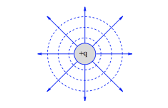 | 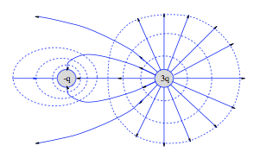

- See below.
  - 1.3 x 10²² N/C directed away from the nucleus
  - 3.8 x 10⁷ V
  - 6.6 x 10⁻¹² J
  - 8.5 x 10⁷ m/s

