Atoms: Lewis Structures: Quiz 6c

/5

Draw Lewis Structures for the following:

- C | - SF₆
- H₂C₂

Answers:

- C | - SF₆
 | 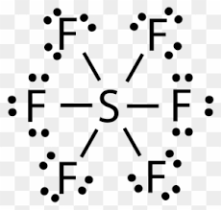
- H₂C₂
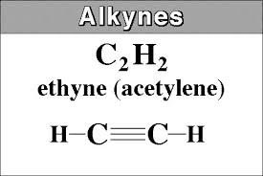

With only 10 electrons they need to be shared more in order to satisfy valence shells!

