Atoms: Lewis Structures: Quiz 6b

/5

Draw Lewis Structures for the following:

- Beryllium | - XeF₄
- NO₂⁻¹

Answers:

- Beryllium | - XeF₄
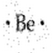 | 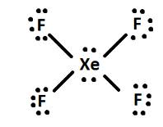
- NO₂⁻¹

