Atoms: Lewis Structures: Quiz 6a

/5

Draw Lewis Structures for the following:

- Sulphur | - BrF₃
- NO₃⁻¹

Answers:

- Sulphur | - BrF₃
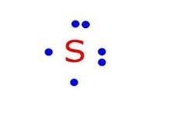 | 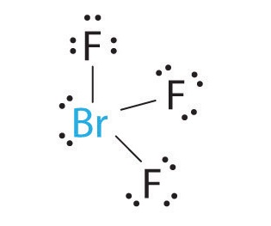
- NO₃⁻¹

