Solutions Chem:
Shapes of Molecules (ADV): Quiz 3b

/5

Answer the following:

- Complete the table below:

Molecule | 3D Shape (draw it!) | Bonding Pairs | Lone Pairs on Central Atom | Name | Polar or Non-Polar
XeF₄

*Double Bonds are treated as single bonds for repulsion purposes!

Answers:

- Complete the table below:

Molecule | 3D Shape (draw it!) | Bonding Pairs | Lone Pairs on Central Atom | Name | Polar or Non-Polar
XeF₄ | 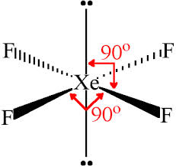 | 4 | 2 | Square Planar | Non-Polar

*Double Bonds are treated as single bonds for repulsion purposes!

