Atoms: Orbital Diagrams: Quiz 2a

/5

Please show work where necessary!

- How many electrons can each of the following orbitals hold?

a. 2s = ________

b. 5f = ________

- What is the maximum number of electrons in the 3rd principal energy level? __

- Draw the orbitals below and then fill in the orbital diagram for the element Fe:

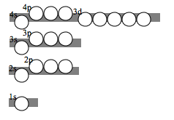

Answers:

- How many electrons can each of the following orbitals hold?

a. 2s = ____2_____

b. 5f = ____14____

- What is the maximum number of electrons in the 3rd principal energy level? _18_

- Draw the orbitals below and then fill in the orbital diagram for the element Fe:

