Worksheet 5.5 – Gravitational Potential Energy, Satellites

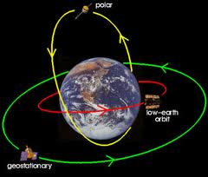 | 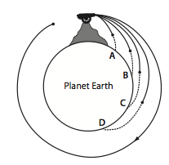

- What is the gravitational potential energy (relative to infinite) of a 5.00x10³ kg satellite that is in orbit with a radius of 9.90x10⁶ m around the Earth?

- How much work is done against gravity in lifting the satellite in problem #5 from Earth’s surface to its orbital height?

- A 1750 kg meteorite is 15000 m above the surface of the moon, heading directly towards the moon at 1.00x10³ m/s. What is its speed on impact?

- What is the gravitational potential energy of a 10.0 kg object when it is sitting on Earth’s surface

- Calculate escape velocities for the Sun, the Moon, and Mars, given the following information.

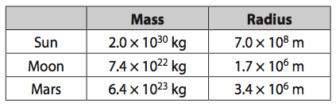

- Travelling to other planets involves not only Earth’s gravitational field but also that of the Sun and the other planets. Would it be easier to travel to Venus or to Mars?

- What is the escape velocity of a 1300 kg shuttle taking off from the moon?
- What is the mass of a planet that has an escape speed of 9.0x10³ m/s and a radius of 7.2x10⁶ m?
- A 12500 kg satellite is in Earth orbit at an altitude of 3.60x10⁶ m. What is its total energy?
HINT: Total Energy = E_{p} + E_{k}

Answers:

- (-2.0x10¹¹ J)
- (1.11x10¹¹ J)
- (1.02x10³ m/s)
- (-6.25x10⁸ J)
- Sun = 6.2 x 10⁵ m/s , Moon = 2.4 x 10³ m/s , Mars 5.0 x 10³ m/s
- Venus would be easier. To go to Mars you must also move away from the sun. Towards Venus the sun’s gravitational pull helps you!
- (2.37x10³ m/s)
- (4.37x10²⁴ kg)
- (-2.50x10¹¹ J)

