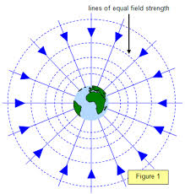
Worksheet 5.4 – Gravitational Field Strength

G = 6.67 × 10⁻¹¹ N m² kg⁻², mass of the Earth = 6.0 × 10²⁴ kg, Radius of the Earth = 6.4 × 10⁶ m.

- Calculate the gravitational field strength on the surface of the earth.

- Calculate the gravitational field strength Mr. Lawson would generate if he had the same radius of the Earth. (Oh by the way I weigh 80.0 kg)

- Based on your answers to Q 1 and 2… explain why the Earth and I exert the SAME force on one another…

- Calculate the gravitational field strength on the surface of Mars. Mars has a radius of 3.43x10⁶ m and a mass of 6.37x10²³ kg.

- At what distance from Earth’s surface is the acceleration due to gravity 7.33 m/s²?
- On the surface of Planet X an object has a mass of 22.5 kg and a weighs 63.5 N. What is the gravitational field strength on the surface?

- On the surface of Planet Y, which has a mass of 4.83x10²⁴ kg, a 30.0 kg object weighs 50.0 N. What is the radius of the planet?

Answers:

- (9.8 m/s² duh…)
- (1.3 x 10⁻²² m/s²)
- the actual force acting on an object at a point in a field is the product of the field strength and the mass of the object placed there. This product is the same in both situations
- (3.61 N/kg)
- (9.97x10⁵ m)
- (2.82 N/kg)
- (1.39x10⁷m)

