The following Worksheet package is Review from Physics 11. As always show all work, including diagrams, knowns, and equations.
Worksheet 4.1b – Law of Conservation of Energy
Use the Law of Conservation of Energy to solve the following problems.
Ek_{i} + Ep_{i} + W = Ek_{f} + Ep_{f}

- Physics student is dropped (don’t ask why or you’re next). If they reach the floor at a speed of 3.2 m/s, from what height did they fall?

- A heavy object is dropped from a vertical height of 8.0 m. What is its speed when it hits the ground?

- A bowling ball is dropped from the top of a building. If it hits the ground with a speed of 37.0 m/s, how tall was the building?

- A safe is hurled down from the top of a 1.3 x 10² m building at a speed of 11.0 m/s. What is its velocity as it hits the ground?
4.0 m
9.0 m

- A box slides down a frictionless ramp. If it starts at rest, what is its speed at the bottom?

- A pendulum is dropped from the position shown, 0.25 m above its equilibrium position. What is the speed of the pendulum bob as it passes through its equilibrium position?
1.00 m
0.25 m

30º
12.0 m

- A box slides down a frictionless incline as shown. If the box starts from rest, what is its speed at the bottom?

12.0 m
2.0 m
4.0 m
A
B
C
- A roller coaster car starts from rest at point A. What is its speed at point C if the track is frictionless?

- A 2.5 kg object is dropped from a height of 10.0 m above the ground. Calculate the speed of the object as it hits the ground.

- An 80.0 kg student running at 3.5 m/s grabs a rope that is hanging vertically. How high will the student swing?

- A pendulum is 1.20 m long. If the pendulum is pulled until it makes a 25.0º angle to the vertical, what is the speed of the pendulum bob when it passes through its equilibrium position? HINT: Determine the vertical drop of the pendulum bob first.
25.0º

- A new roller coaster has come to the PNE in Vancouver as shown in the diagram below. The speed of the roller coaster at point A is 4.0 m/s.

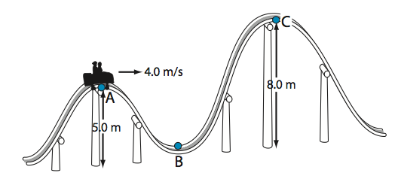
  - What is its speed at point B?
  - Is the roller coaster going fast enough to get to the top of the second hill (point C)?
  - How fast does the roller coaster have to be going at point B to make it to the top of the second hill?
  - Why don’t you need to know the mass of the roller coaster?

- 0.52 m 2) 13 m/s 3) 69.8 m 4) 52 m/s 5) 8.9 m/s 6) 2.2 m/s 7) 10.8 m/s 8) 13 m/s 9) 14 m/s 10) 0.63 m 11) 1.5 m/s
12) a. 10.7 m/s b. No c) 12.5 m/s d. Masses CANCEL in final calculations!

