Worksheet - Electric Fields on Multiple Charges

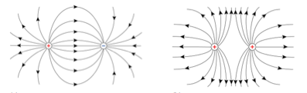

- Calculate the electric field strength midway between a 4.50 μC charged object and a -4.50 μC charged object if the two charges are 50 cm apart.

- Calculate the electric field strength midway between a 3.0 μC charged object and a 6.0 μC object if they are 0.80 m apart.

- Calculate the electric field strength midway between two 3.0 μC objects if they are 90 cm apart.
- Two negatively charge spheres, A and B, are 30 cm apart and have the following charges of 3.0 x 10⁻⁶ C and 1.5 x 10⁻⁶ C as in the figure below. What is the net electric field at a point P, which is exactly in the middle between the two charges?

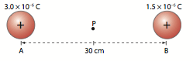

- What is the magnitude and direction of the electric field at point P in the figure below?

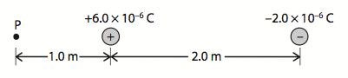

Answers:

- (1.30x10⁶ N/C)
- (1.7x10⁵ N/C)
- (0 N/C)
- (6.0 x 10⁵ N/C to the right)
- (5.2 x 10⁴ N/C to the left)

