Worksheet 1.5 – Projectiles

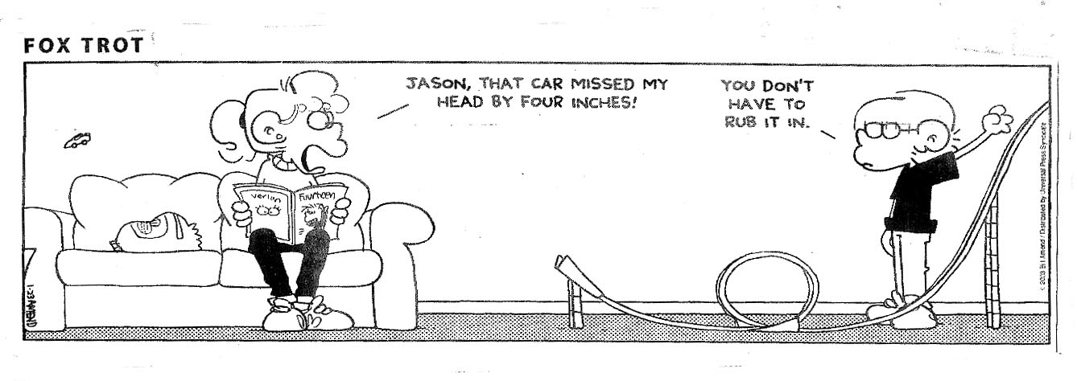

HINT: the gatekeeper between the horizontal and vertical components of projectile motion is TIME!

- A golf ball was struck from the first tee at Lunar Golf and Country Club. It was given a velocity of 48 m/s at an angle of 40˚ to the horizontal. On the moon, g = -1.6 m/s².
- What are the vertical and horizontal components of the ball's initial velocity?
- For what interval of time is the ball in flight?
- How far will the ball travel horizontally?

- A batter hits a ball giving it a velocity of 48 m/s at an angle of 50˚ above the horizontal.
- What are the vertical and horizontal components of the ball's initial velocity?
- How long is the ball in the air?
- What is the horizontal distance covered by the ball while in flight?
- What velocity does the ball have at the top of its trajectory?

- An archer standing on the back of a pickup truck moving at 28 m/s fires an arrow straight up at a duck flying directly overhead. The archer misses the duck! The arrow was fired with an initial velocity of 49 m/s relative to the truck.
- For how long will the arrow be in the air?
- How far will the truck travel while the arrow is in the air?
- Where, in relation to the "duckless" archer, will the arrow come down? Will the archer have to 'duck'?

- A ball is thrown with a velocity of 24 m/s at an angle of 30˚ to the horizontal.
- What are the vertical and horizontal components of the initial velocity?
- How long is the ball in the air?
- How far away will the ball land?
- To what maximum height will the ball rise?
- With what velocity will the ball land?

- A pebble is fired from a slingshot with a velocity of 30 m/s. If it is fired at an angle of 30˚ to the horizontal, what height will it reach? If its flight is interrupted by a vertical wall 12 m away, at what height will it hit the wall?

- A diver takes off with a speed of 8.0 m/s from a 3.0 m high diving board at 30˚ above the horizontal. How much later does she strike the water?

- On level ground, a ball is thrown forward and upward. The ball is in the air 2.0 s and strikes the ground 30 m from the thrower. What was the ball's initial velocity?

- A golf ball was struck from the first tee at Lunar Golf and Country Club, a private golf course for astronauts stranded on the moon. It was given a velocity of 48 m/s at an angle of 40º to the horizontal. On the Moon, the magnitude of g = 1.6 m/s².

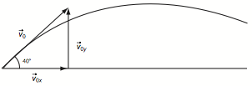

  - What is the verticle component of the golf ball’s initial velocity?
  - For what interval of time is the ball in flight?
  - How far will the ball travel horizontally?

- A girl throws a rock horizontally from the top of a cliff 98 m high, with a horizontal velocity of 27 m/s.
  - How many seconds will the rock be in the air?
  - How far out from the base of the cliff does the rock land?

- A daredevil BMX rider rides his bike off a cliff with a horizontal velocity of 4.5.0 m/s, and lands in the water 12.0 m from the base of the cliff.
  - How long does it take the rider to hit the water?
  - How high is the cliff?

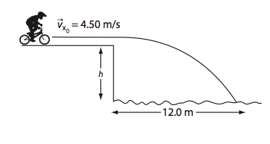

Worksheet 1.5 ANSWERS

- Vx = 36.8 m/s; Vyo = 30.8 m/s
- a. Vx = 30.8 m/s; Vyo = 36.8 m/s b. 7.50 s c. 231 m d. 30.8 m/s horizontal
- 5) a. 10.0 s b. 279 m c. Oh Yeah!
- a. Vx = 20.8 m/s; Vyo = 12 m/s b. 2.45 s c. 50.9 m d. 7.34 m e. 24 m/s 30º below horiz
- 11 m High
- 1.28 s
- 17.9 m/s 33º above horiz
- a. 31/ m/s b. 39 s c. 1.4 x 10³ m (1.4 km)
- a. 4.5 s b. 1.2 x 10² m
- a. 2.67 s b. 34.8 m

