- What value is constant for both the horizontal and vertical components of a projectiles motion?
  - Displacement
  - Acceleration
  - Velocity
  - Time
- The acceleration due to gravity acts:
  - Upward
  - Downward
  - Depends on the motion of the object
  - Towards outer space
- A bullet is fired at an angle of 45⁰. Neglecting air resistance, what is the direction of acceleration during the flight of the bullet?
  - Upward
  - Downward
  - Depends on the motion of the object
  - At an angle of 45⁰
- A rocket is fired at 30⁰. If the initial horizontal velocity is 326 m/s, what is the initial vertical velocity?
  - 188 m/s
  - 330 m/s
  - 380 m/s
  - 250 m/s
- A golfer drives her golf ball from the tee down the fairway in a high arcing shot. When the ball is at the highest point of its flight
  - The velocity and acceleration are both zero
  - The x-velocity is zero and the y-velocity is zero
  - The x-velocity is non-zero and the y-velocity is zero
  - The velocity is non-zero and the acceleration is zero
- A soccer ball is kicked at a 55⁰ angle with an initial velocity of 8.0 m/s. What is the vertical velocity of the ball as it hits the ground?
  - 8.0 m/s
  - -6.6 m/s
  - -8.0 m/s
  - cannot be determined from given information
- For a projectile, what is the acceleration in the x-direction?
  - Depends on initial velocity
  - 0 m/s²
  - Depends on how long it is in the air
  - Depends on the y-acceleration
- A bullet is fired horizontally from a gun. At the same time a similar bullet is dropped from the same height. The fired bullet will:
  - Hit the ground first
  - Hit the ground second
  - Hit at the same time as the dropped bullet
  - Never hit the ground
- A 10-kg weight and a 100-kg weight of the same size are dropped from the roof of a building. Which will hit first? (Ignore air resistance)
  - They will hit at the same time
  - The 100-kh weight
  - The 10-kg weight
  - Cannot be determined from the given information

Answer each question as completely as possible. Neglect air resistance. Show all work, including a drawing (with positive/negative direction indicated), and an x-y table. Start with equations in general form (without numbers!), include the correct units and box your final answer.
- An egg is thrown horizontally off the roof of SI, which is 20. meters high, with an initial velocity of 6.5 m/s. How far from the base of the building does the egg land?
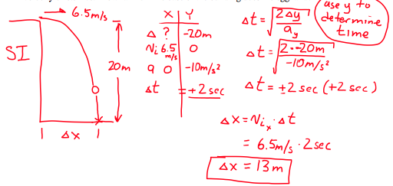

- A car drives horizontally off a cliff 80. meters high. The car lands 100. meters from the base of the cliff. How fast was the car traveling when it left the cliff?

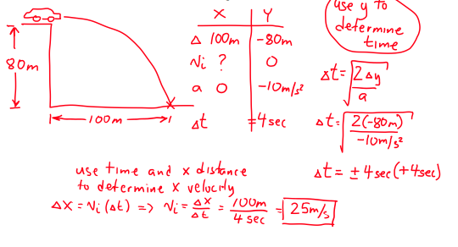

- A cannonball is fired from the ground at an angle of 60⁰ with an initial velocity of 200.0 m/s. What is the maximum height reached by the cannonball? How far will the cannonball travel before returning to the ground?
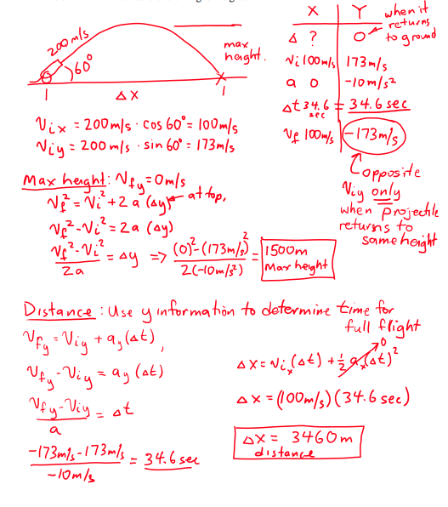

- A ball is thrown from a height of 2 meters at an angle of 30⁰ with an initial velocity of 30. m/s toward a building 65 meters away. How high from the base of the building does the ball hit? Is the ball rising or falling as it hits the building?

