Quiz 5b: Functional Groups and Isomerism

/5

Name the following Organic Compounds:
- 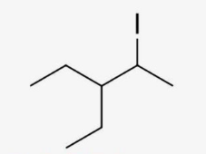
- 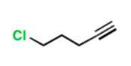
- 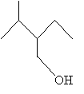
DRAW and NAME 2 isomers of C₄H₁₀:

Name the following Organic Compounds:
3-ethyl-2-iodo-pentane
5-chloro-1-pentyne
2-ethyl-3-methyl-1-butanol
DRAW and NAME 2 isomers of C₄H₁₀:
