Quiz 5a: Functional Groups and Isomerism

/5

Name the following Organic Compounds:
- 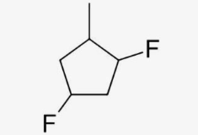
DRAW and NAME 3 isomers of C₅H₁₂:

Name the following Organic Compounds:
1,4-difluro-2-methylcyclobutane
2,6,8-trimethyl-4-nonanol
DRAW and NAME 3 isomers of C₅H₁₂:
