Quiz 2c: Branched Chain Alkanes

/5

Name the following Branch-Chain Alkanes:
- 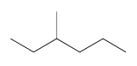
- 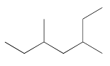
- 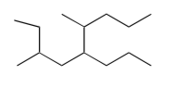

Draw the following Branch-Chain Alkanes:
- 2,2,3,3-tetramethylpentane
- 3-methyl-5-propylnonane
Name the following Branch-Chain Alkanes:
3-methylhexane
3,5-dimethylheptane
3,6-dimethyl-5-propylnonane

Draw the following Branch-Chain Alkanes:
- 2,2,3,3-tetramethylpentane | 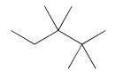
- 3-methyl-5-propylnonane | 