Quiz 2b: Branched Chain Alkanes

/5

Name the following Branch-Chain Alkanes:
- 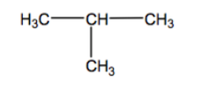
- 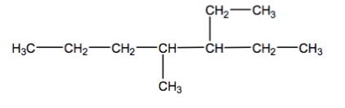
- 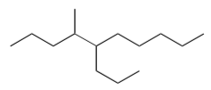

Draw the following Branch-Chain Alkanes:
- 2,3-dimethylbutane
- 4-ethyl-3,6-dimethyloctane
Name the following Branch-Chain Alkanes:
2-methylpropane
3-ethyl-4-methylheptane
4-methyl-5-propyldecane

Draw the following Branch-Chain Alkanes:
- 2,3-dimethylbutane
- 4-ethyl-3,6-dimethyloctance | 