Quiz 2a: Branched Chain Alkanes

/5

Name the following Branch-Chain Alkanes:
- 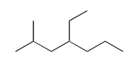
- 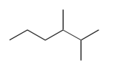
- 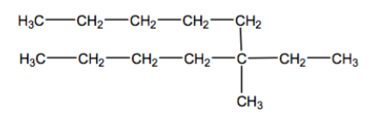

Draw the following Branch-Chain Alkanes:
- 4-ethyl-2,3-dimethylheptane
- 2-methylpropane

Name the following Branch-Chain Alkanes:
4-ethyl-2-methylheptane
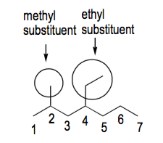
2,3-dimethylhexane

5-ethyl-5-methyldecane

Draw the following Branch-Chain Alkanes:
- 4-ethyl-2,3-dimethylheptane | 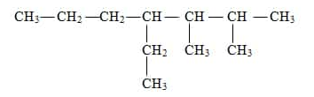
- 2-methylpropane

