Quiz 1c: Branched Chain Alkanes

/5

Fill in the blanks of the following table:
Alkane & Formula | Structural Formula | Condensed Structural Formula | Carbon Skeleton Formula
Propane  C₃H₈ |  | 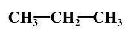
 | 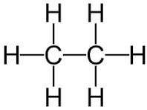
 |  |  | 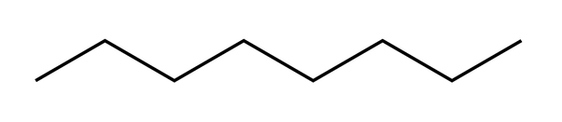
Decane
C₁₀H₂₂

Answers: (1/2 mark for each right answer)

Fill in the blanks of the following table:
Alkane & Formula | Structural Formula | Condensed Structural Formula | Carbon Skeleton Formula
Propane  C₃H₈ | 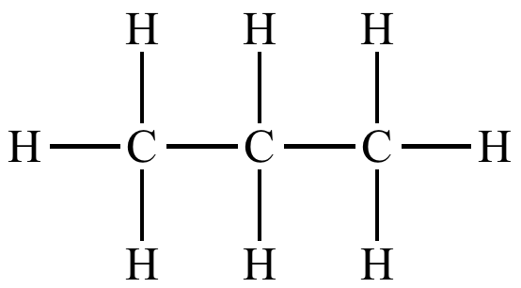
Ethane  C₂H₆ |  | 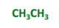
Octane  C₈H₂₀ | 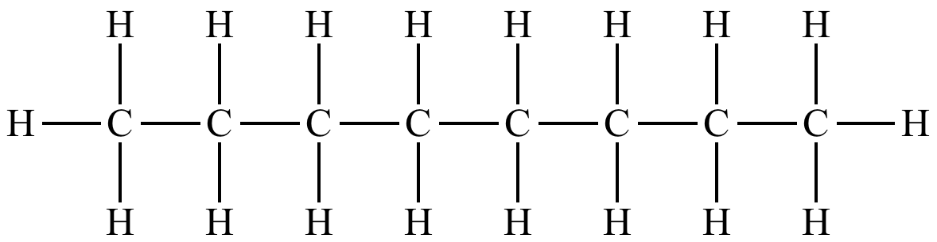 | 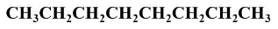
Decane  C₁₀H₂₂ | 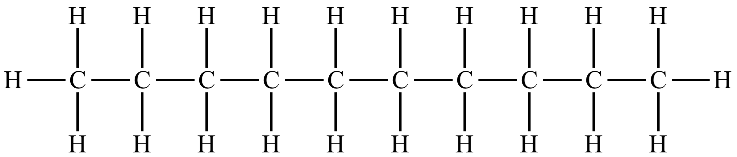 | 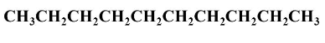 | 