**Electromagnetism Notes**

1 – Magnetic Fields

Magnets can _________________ or _______________ other magnets.

They are able to exert forces on each other without touching because they are surrounded by ____________________ _________________.

**Magnetic Flux** refers to…

Areas with many lines have __________________ magnetic field.

Magnets have two different ends called ___________________, either as_________________ (N) or ___________________ (S).



It is important to note that magnetic fields are ____________________ and therefore we need to represent the lines as…

In fact we define the direction of a magnetic field as …

This is very much like electric charges; however there is a very important difference between these two.

Electric charges can be…

Whereas magnetic poles…

**N S**

We can sum up the behaviour of interacting magnetic fields:

(1)

(2)

**Consider a compass:**

A compass is useful because its needle always points north. This is because the needle is a ________________ and so is ______________.

Yeah fine but WHY does it point north?

Well, the north pole of the compass will…

Well that’s all very well for magnetism, but where does the electro come in?

It turns out that any….

In fact a current carrying wire will have a very regular   
magnetic field around it as predicted by the:

**1st Right Hand Rule:**

Thumb:

Fingers:

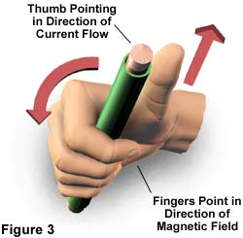

Often we will represent a current carrying wire simply as though you were looking at it end on. In this case we simply draw it as a circle. To indicate the direction of current flow we draw a ____ if it is in to the page and a ____ if it is out of the page.

If it helps to remember which is which think of an ________________!

Below shows current carrying wires (lines) and compasses (circles). Draw arrows to show which direction the compasses will point.



Note that the compass always points…

**Domains:**

We have seen that the movement of electrons can create a magnetic field, but how does this apply to permanent magnets like bar magnets?

Certain metals (iron, nickel and cobalt) have…

In a piece of these metals the spins of unpaired electrons align in areas called domains. In an unmagnetized piece of metal the domains are lined up randomly. A magnet is created when these domains are aligned in one direction.



**Solenoids:** aka _____________________

A solenoid is simply…

The many loops of wire each carry current and therefore…

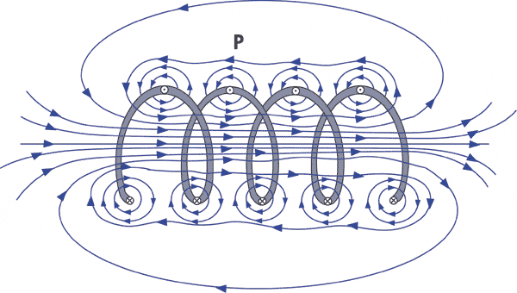

**The 2nd Right Hand Rule:**

Fingers: Thumb:

Note when using any right hand rules that…

Just as with a bar magnet a solenoid has…

Note from the diagram that the field outside of a solenoid is _____________ and ______ _______________ especially if its ________________ is much greater than its _____________.

However the magnetic field inside the solenoid is ________________ and _________________________.

In a uniform magnetic field INSIDE a solenoid we can calculate the strength of the field using:

Where : B =

=

I =

n =

Example:

A hollow solenoid is 25 cm long and has 1000 loops. If the solenoid has a diameter of 4.0 cm and a current of 9.0 A what is the magnetic field in the solenoid?

**Electromagnetism Notes**

2 – Magnetic Forces on Wires and Charges

With permanent magnets _______________ poles attract and ________________ poles repel.

As we have seen magnetic fields surround any…

Therefore it stands to reason that magnetic forces will act on wires carrying __________________ _____________________ and charged particles moving in ______________________ _________________.

Parallel Current Carrying Wires

Picture two parallel wires carrying current in the same direction, would the fields produced by these wires attract or repel?

Parallel wires with current flowing in the **same** direction will…

The same logic can be used to determine how parallel wires containing currents the flow in the opposite direction interact.

Parallel wires with current flowing in the **opposite** directions will…

Current Carrying Wires in Magnetic Fields

A current carrying wire in a magnetic field will also experience…

Imagine a current carrying wire placed between two permanent magnets.

Note that **above the wire** both the permanent magnetic field and the field generated by the wire point…

These two fields will ____________________.

Also, **below the wire** the permanent magnetic field and the field generated by the wire point…

These two fields will ____________________.

The magnitude of the magnetic force on a conductor can be calculated as:

Where:

B =

I =

l =

~~0~~ =

Note that if the conductor is perpendicular to the magnetic field this formula becomes:

Because…

If the conductor is parallel to the magnetic field then…

**The 3rd Right Hand Rule**:

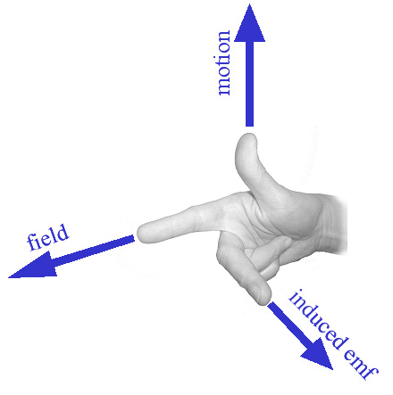

force

Moving Charges in Magnetic Fields

In the same way that charged particles moving through a wire will experience a force in a magnetic field, so will free charged particles.

To determine the direction of the force on such a particle we simply use…

NOTE: We use the right hand rules for wires when talking about ____________________ ___________________ and the left hand rules for wires when talking about ________________ _______________.

We follow the same logic when dealing with charged particles:

For **positive** particles use… For **negative** particles use…

To calculate the magnetic force on the particle we use:

Where: q =

v =

B =

~~0~~ =

NOTE: Just like the magnetic force on conductors this formula can be reduced to

when the particles are moving _________________ to the magnetic field.

If a charged particle enters a magnetic field traveling perpendicular to the field, it will deflect continuously and travel in a _____________________.

Consider an **electron** moving through a magnetic field

Now consider a proton moving through the same magnetic field

X X X X

X X X X

X X X X

X X X X

X X X X

X X X X

X X X X

X X X X

Example:

Circular particle accelerators use magnetic fields to bend beams of charged particles. This allows them reach phenomenal speeds in relatively small spaces. The cyclotron at UBC’s TRIUMF contains the largest of its kind in the world. It accelerates a beam of hydrogen anions (H-) to 75% the speed of light and uses a 0.42 T magnetic field. Note that at these speeds the relativistic mass of a hydrogen anion is 2.524x10-27 kg.

What is the outer radius of the cyclotron?

**When charged particles travel in a circular path:**

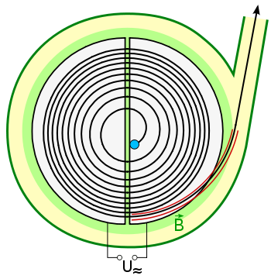

**Electromagnetism Notes**

3 – Motors and Galvanometers, CRTs and Mass Spectrometers

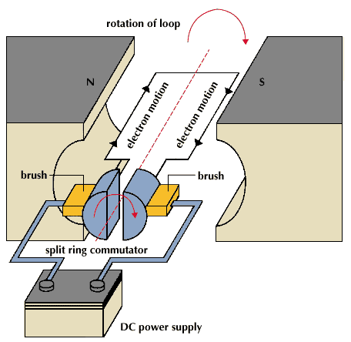

**Motors**

We have seen that a current carrying wire perpendicular to a magnetic field will experience a _________________.

This phenomenon is used by an electric motor to transform ______________ energy into ______________ energy.

A simple DC motor consists of a loop of wire that passes through a magnetic field. The ends of the loop are attached to a split ring (______________________) which turns with the loop. Fixed ______________________ connect the commutator to the voltage source.

The commutator (split ring) is important because…

**Galvanometers**

A galvanometer is an instrument used to detect electric current. A galvanometer calibrated to measure current is called an ________________

while one that measures voltage is called a ___________________.

These devices also make use of the motor principle.

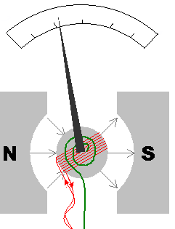

**Essentially**, a current carrying wire in a magnetic field will experience a force proportional to the ______________________.

As shown on the right, when a current flows through the wire the needle will experience a force. The needle is attached to a spring which provides a restorative force. As the coil rotates against the spring a reading is produced

A galvanometer can be converted into an **ammeter** by placing a shunt (wire) of low resistance parallel to the coil. In other words a parallel path for electrons so that only a small fraction of electrons flow through the coil.

A galvanometer can be converted into a **voltmeter** by placing a shunt (wire) of high resistance in series with the coil. This greatly reduces the current that flows through the meter.

**Cathode Ray Tubes**



Recall from the earlier unit on electrostatics that a cathode ray tube is used to accelerate electrons to incredible speeds and then deflect them with electrically charged plates. Consider the following example:

1) The electron beam is produced by accelerating electrons through an electric potential difference of 380 V. What is the speed of the electrons as they leave the 380 V plate?

2) What is the electrostatic force on electrons in the region between the horizontal plates when they are connected to a 9.0 V potential difference?

**Determining the Mass and Charge of the Electron**

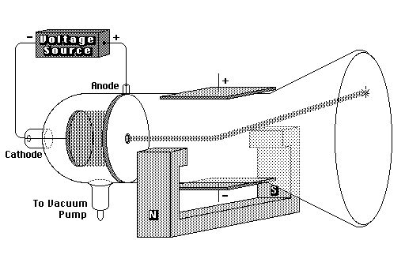

Famed physicist J.J. Thompson took the cathode ray a step further. First he set up a cathode ray tube that deflected the electron ray using a second set of electrically charged plates (aka yoke), similar to the example above.

As expected the ray deflected towards the positive plate.

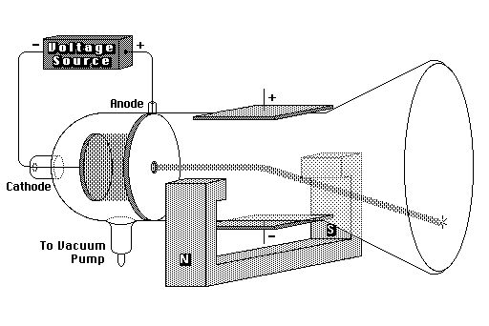

He then disconnected the current from the electric yoke and instead sent current through an electromagnet flanking the cathode ray. He was intrigued to note that the ray of electrons deflected downwards.

Since r and B can both be easily measured we could simply determine the speed of the electron by

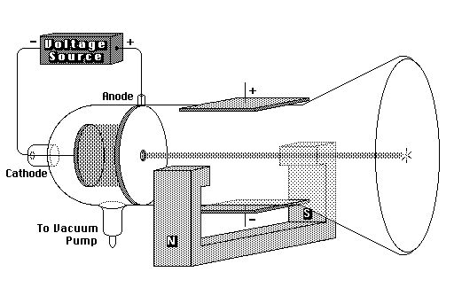Unfortunately for good old J. J., nobody knew the mass or charge of an electron. Both of which would be needed to determine the velocity of the electron ray.

But then, he weren’t no genius for nothin’. He set up another cathode ray that had both electromagnetic and electrostatic yokes working in opposition to each other.

By gently calibrating the electric field between the plates, he was able to obtain an undeflected beam as shown:

In this case where the electrons are undeflected, we know that the electrostatic and magnetic forces are _______________________

Or simply, ______________. This can be used to solve for the velocity of the electrons, which in turn allowed Thompson to determine the charge to mass ratio of the electron long before either quantities were understood.

Example: Charged particles traveling horizontally at 3.60x106 m/s when they enter a vertical magnetic field of 0.710 T. If the radius of their arc is 9.50x10-2 m, what is the **charge to mass** ratio of the particles?

Example: What is the speed of an electron that passes through an electric field of 6.30x103 N/C and a magnetic field of 7.11x10-3 T undeflected? Assume the electric and magnetic fields are perpendicular to each other.

**Mass Spectrometers**

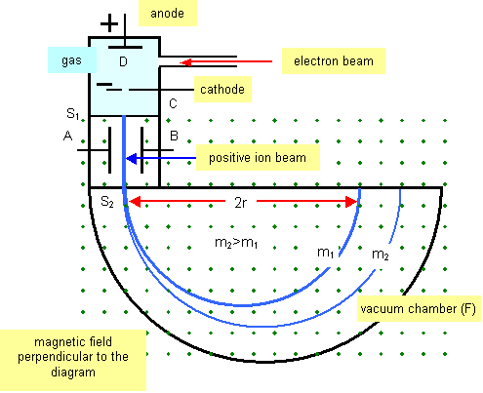

Mass spectrometers can be used to determine the mass of unknown substance or to separate similar compounds of slightly different mass. First the sample is vaporized and then it is bombarded with electrons. These high energy electrons ionize the sample by knocking loose electrons. These cations are then accelerated by a potential difference and then fired into a perpendicular magnetic field. This field causes them to bend until they strike a detector.

How can this be used to determine the mass of an unknown sample?

In practice even a pure substance will strike the detector at multiple locations. Explain why this might occur.

Mass spectrometers can also be used to separate substances into individual isotopes. For example uranium naturally exists as a mixture of Uranium-238 and Uranium-235. Describe how this is done. On the diagram above, which paths (m1 or m2) would represent U-235 and U-238?

**Electromagnetism Notes**

4 – Electromagnetic Induction

After scientists had discovered that an electric current can generate a magnetic field the logical question followed:

*“If an electric current can generate a magnetic field, can a magnetic field generate an electric current?”*

Michael Faraday and Joseph Henry independently discovered they could.

Another example of this comes when you move a bar magnet into or out of a hollow solenoid.

When the magnet is moved one way the current is in one direction and when it is moved the other way the current reverses.

To predict the direction of the induced current we use **Lenz’s Law**:

**Electromagnetic Induction:**

Faraday discovered many ways to induce a current. For example in the induction coil shown below.

What was most interesting to note was that…

This showed that magnetic fields do not simply create electric currents, rather they are only generated by…

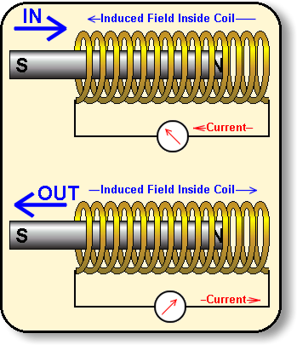

Lenz’s Law is really an application of…

Remember that we can use the **2nd Right Hand Rule** to relate the poles of an electromagnet and the direction of current flow.

Thumb: Fingers:

As we said the electric current is generated by a…

In order to calculate the EMF generated we need to use the idea of magnetic flux.

**Magnetic Flux:**

For a loop of wire in a magnetic field the magnetic flux depends on:

(1)

(2)

(3)

Note that magnetic flux is at a **maximum** when the loop is…

And at a **minimum** when the loop is…

As we said before an EMF is produced by a changing magnetic field, specifically by a changing flux. In fact,

Where: N =

And the “–“ sign relates to…

Magnetic flux can be calculated by:

Where:

Φ =

B =

A =

~~0~~ =

The units of flux are Tm2 or the Weber (Wb)

Example:

A 1.80 diameter circular coil that contains 50 turns of wire is perpendicular to a 0.250 T magnetic field. If the magnetic field is reduced to zero in a time of 0.100s what is the average induced EMF in the coil?

Example:

A square loop of wire is perpendicular to a 1.50 T magnetic field. If each side of the wire is 2.10 cm, what is the magnetic flux through the loop?

Example:

A circular loop of wire radius 2.5 cm is placed in a magnetic field B = 0.020 T into the page. The field is then reduced to 0.010 T into the page in 0.10 s.

a. What is the average induced EMF?

b. Which direction does the current flow?

**Electromagnetism Notes**

5 – Moving Conductor

We have already seen that a loop rotating in a magnetic field will generate an EMF according to Faraday’s Law ( )

However when considering a conductor moving in a magnetic field it is better to consider a different form of this equation.

For Moving Conductors:

Where:

ε =

B =

l =

v =

**Derivation**:

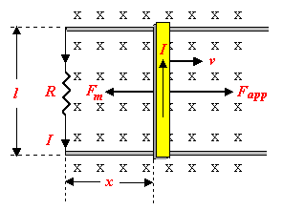

Example:

A conducting rod 15 cm long moves at a speed of 2.0 m/s perpendicular to a 0.30 T magnetic field. If the resistance of the circuit is 4.0 ohms, what is the magnitude of the current through the circuit?

Example:

A conducting rod 25.0 cm long moves perpendicular to a magnetic field (B = 0.20 T) at a speed of 1.0 m/s. Calculate the induced EMF in the rod.

Example:A 0.75 m conducting rod is moved at 8.0 m s across a 0.25 T magnetic field along metal rails. The electrical resistance of the system is 5.0 Ω. What are the magnitude and direction of the current through point X?

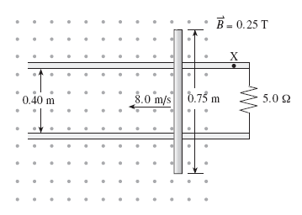

**Electromagnetism Notes**

6 – Back EMF

Devices that use mechanical energy to induce an electric current are called ________________________. Many kinds of mechanical energy can therefore by converted into electrical energy such as in:

___________________________ and ___________________________.

Note that this works in the exact opposite manner as an electric motor.

Motor: _____________________ energy to _________________ energy

Generator: __________________ energy to _________________ energy

Notice that these generators produce __________________ current because…

Remember that to determine the direction of the current through a loop we can use ___________________ _______________ _____________ and to determine the EMF produced by a loop we can use _____________________________ _____________ ( ).

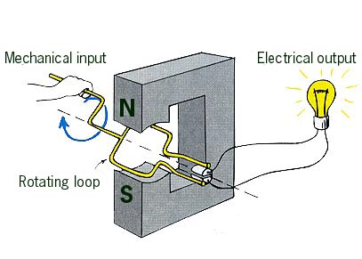

This brings up an inherent problem with all electric motors. As we said, electric motors are basically _________________ of ______________ rotating in a _____________________ ______________.

However, we know that whenever we rotated wires in a magnetic field we generate an ___________________ __________________.

Back EMF can be calculated using:

Where: Vback =

ε =

I =

r =

We also know from Lenz’s Law that the induced EMF works in the ________________ ___________________.

This is called:

And it always works…

Example: A 120 V motor draws 12 A when operating at full speed. The armature has a resistance of 6.0 ohms.

a) Find the current when the motor is initially turned on.

b) Find the back EMF when the motor reaches full speed.

Example:

The diagram shows a 0.010 kg metal rod resting on two long horizontal frictionless rails which remain 0.40 m apart. The circuit has a resistance of 3.0  and is located in a uniform 0.20 T magnetic field.

a) What is the initial acceleration of the bar?

b) What is its top speed?



Example:

The diagram below shows a pair of horizontal parallel rails 0.12 m apart with a uniform magnetic field of 0.055 T directed vertically downward between the rails. There is a glider of mass 9.5x10-2 kg across the rails. The internal resistance of the 75 V power supply is 0.30 ohms and the electrical resistance of the rails and the glider is negligible. Assume friction is also negligible.

a) What is the initial acceleration of the glider?

b) What is the value of the terminal velocity as limited by the back emf produced by the moving glider?



**Electromagnetism Notes**

7 – Transformers

When we generate power we ramp up the voltage for transmission (up to 100 000V) and then when it arrives at homes we ramp it back down for convenient use (120V).

Say we need to transmit a certain amount of power (P = IV)

* a high voltage means a low current.
* since power lost by the wire due to   
  resistance is Ploss = I2R
* low current means power loss is at a minimum

But how is this done?

To convert voltage to a higher or lower value we use a   
______________________.

This is another important application of…

A transformer consists of a _______________________ coil and a ________________________ coil.

As current flows through the primary coil it produces a _________________ _________________. This magnetic field then induces an _____________________ ________________ in the secondary coil.

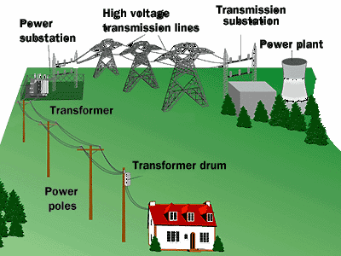

Note that transformers generally only work when using   
_______________ ___________________. If we use   
_________________ ______________ then we need to   
constantly switch the current on and off.

When a transformer increases voltage it is called a…

Note that a step up transformer has…

When a transformer decreases voltage it is called a…

A step down transformer has…

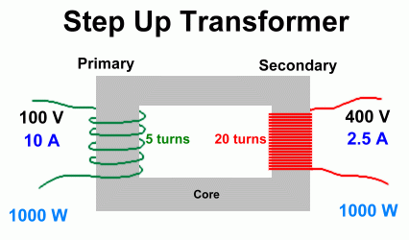

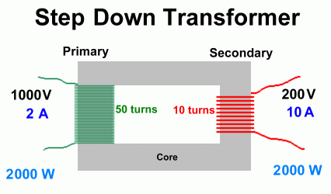

To determine the voltage change we use the following:

Where: Vp =

Vs =

Np =

Ns =

Although we may change the voltage, we must conserve _____________.

Therefore, _________________ must also be conserved. So,

Example:

A step transformer is used to convert 120V to 1.50x104 V. If the primary coil has 24 turns, how many turns does the secondary coil have?

Example:

A step-up transformer has 1000 turns on its primary coil and 1x105 turns on its secondary coil. If the transformer is connected to a 120 V power line, what is the step-up voltage?

Example:

A step-down transformer reduces the voltage from a 120 V to 12.0 V. If the primary coil has 500 turns and draws 3.00x10-2 A,

a) What is the power delivered to the secondary coil?

b) What is the current in the secondary coil?