**Unit 4 – Thermo: Quiz 6a**

/5

1. A 0.500 kg aluminum pan on a stove is used to heat 0.250 liters of water from 20.0 oC to 80.0 oC. How much heat is required? What percentage of the heat is used to heat the pan?
2. A brick oven is 15.0 cm thick. The inside temperature is 350.0 °C. The outside temperature is 25.0 °C. How much heat is lost from one side of the oven in one hour? The side measures 85.0 cm x 60.0 cm. Thermal conductivity of brick?

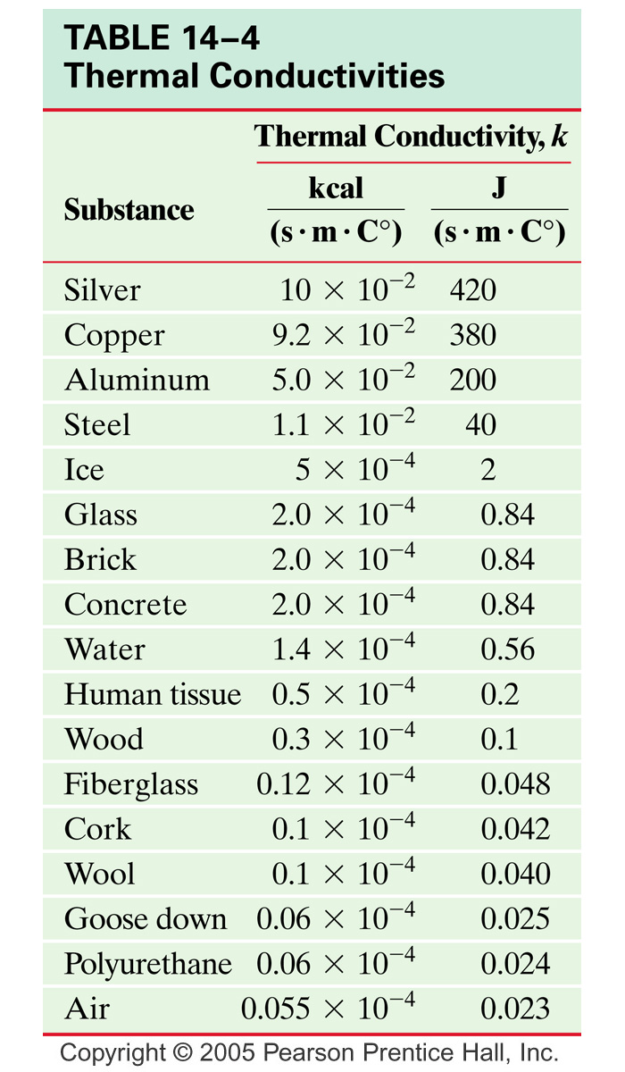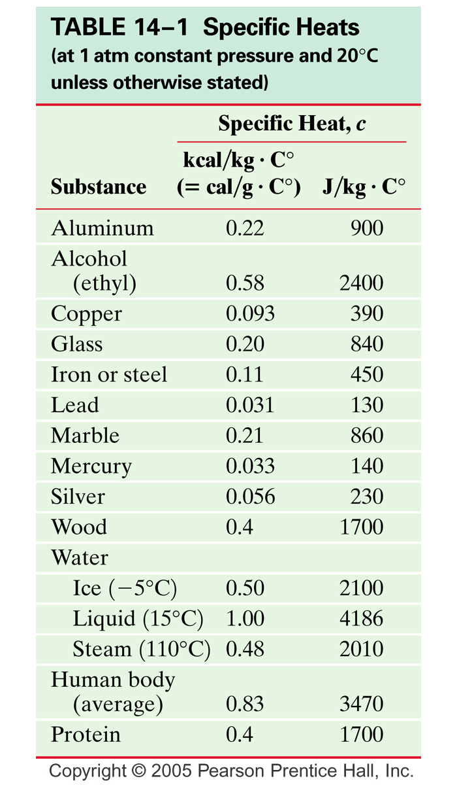

Answers:

1. A 0.500 kg aluminum pan on a stove is used to heat 0.250 liters of water from 20.0 oC to 80.0 oC. How much heat is required?





1. A brick oven is 15.0 cm thick. The inside temperature is 350.0 °C. The outside temperature is 25.0 °C. How much heat is lost from one side of the oven in one hour? The side measures 85.0 cm x 60.0 cm. Thermal conductivity of brick?







