**Unit 4 – Thermo: Quiz 5b**

/5

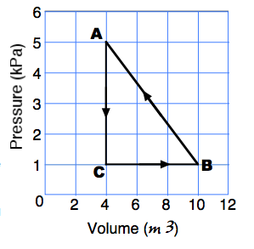

To the right is a P-V diagram that shows multiple step thermodynamic cycle.

1. What is the name of the thermal dynamic process as the gas goes from point “C” to point “A”?
2. What is the name of the thermal dynamic process as the gas goes from point “B” to point “C”?
3. How much **NET work** is done on or by the gas as it undergoes a change along the curve from point “A” to “B” to “C” to “D” and back to “A?”
4. If this process occurs to a system containing 4.0 moles of gas then what is the temperature at location “B”?

Answers:



1. Isochoric
2. Isobaric
3. +12 000 J (on the gas)
4. PV = nRT



