Unit 4 – Thermo: Quiz 5a

/5

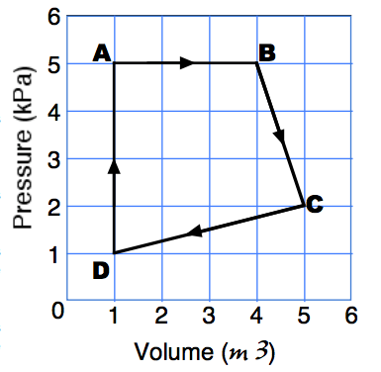
To the right is a P-V diagram that shows multiple step thermodynamic cycle.

- What is the name of the thermal dynamic process as the gas goes from point “A” to point B”?

- What is the name of the thermal dynamic process as the gas goes from point “D” to point “A”?

- How much work is done as a gas undergoes a change along the curve from point “B” to “C?”

- How much work is done as a gas undergoes a change along the curve from point “C” to “D?”

- How much NET work is done on or by the gas as it undergoes a change along the curve from point “A” to “B” to “C” to “D” and back to “A?”

Answers:

- Isobaric
- Isochoric
- 3500 J BY the gas (IMPORTANT!)
- -6000 J BY the gas OR 6000 J ON the gas
- 