The Popsicle Bridge Challenge

Your challenge is to build a bridge that meets the following criteria:

You will be working in groups of 2 or 3 and the challenge will take place over 2 Days

- You must construct a bridge made of popsicle sticks and white glue. No other materials may be used.

- The bridge must span a gap of 50 cm

- The bridge must have a smooth continuous driving deck that spans the entire length of the bridge. This deck must be unobstructed and at least 4 cm wide.

- The bridge must span a gap of 50 cm

- The bridge must be able to hold 5 kg of weight

- Each group shall use no more than 100 popsicle sticks

- You will be graded based on the rubric attached

Day 1: Complete a Scale Drawing of your Bridge (Including Calculations)

Day 2: Build the Bridge

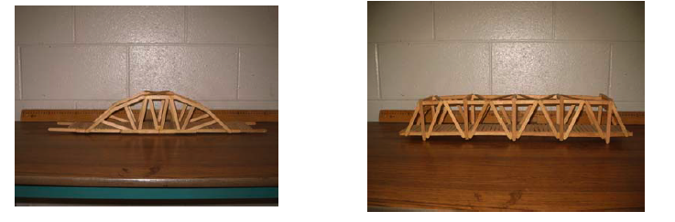

Scale Drawing: (please make a rough copy and SHOW me first before you draw here)

SHOW ALL MEASUREMENTS

Measurement Conversions:

What is the scale factor for your bridge?

Scale Factor: _________________

Show all calculations::

 | Length | Width | Height | Area of driving deck
Centimeters
Millimeters
Inches
Feet

Evaluation:
Criteria | Beginning | Developing | Accomplished | Exemplary
Scale Drawing | - drawing does not show measurements clearly or is inadequately labeled  - rough plan  reflects insufficient  effort | - drawing of bridge is  somewhat clear, but  few measurements  or labels were used  - no effort was made  in keeping the  bridge somewhat to  scale | - drawing of bride is neat with clear  measurements and labeling  - little effort was made in keeping the bridge somewhat to scale. | - drawing of bridge  model is neat and  clear with  measurements and  labeling for all parts (length, width, height, area of driving deck).  - effort was made in  keeping the drawing  somewhat to scale.
Measurements & Conversions | - the length, width, height and area of the driving deck have been measured/calculated  - no conversions were made | - the length, width, height and area of the driving deck have been measured/calculated  - the above measurements were converted into only 2 units of measure | - the length, width, height and area of the driving deck have been measured/calculated  - the above measurements were converted into only 3 units of measure | - the length, width, height and area of the driving deck have been measured/calculated  - the above measurements were converted into all 4 units of measure
Structure | - basic beam bridge (no real design).  - does not span a gap of 50 centimetres (unstable or incomplete).  - width is not at least 4 centimetres.  - did not maximize use of materials (e.g. many popsicle sticks left over). | - beam or arch bridge with limited creative design.  - spans a gap of 50 centimetres, but remains unstable or incomplete in some way.  - width is at least 4 centimetres.  - limited use of materials (e.g. many popsicle sticks left over). | - beam or arch bridge designed with good creativity.  - spans a gap of 50 centimetres, is complete and stable.  - width is at least 4 centimetres.  - good use of materials. | - arch bridge designed with excellent creativity.  - spans a gap of 50 centimetres is complete and stable.  - width is at least 4 centimetres.  - excellent use of materials.
Weight Held | - failed at 2 kilograms or lower. | - failed between 2.5 and 3 kilograms of weight. | - failed between 3.5 and 4.5 kilograms of weight. | - failed at 5 kilograms of weight or more.
Ratio of weight held to weight of bridge | - ratio < 25% of the largest | - 25% of the largest < ratio < 50% of the largest | - 50% of the largest < ratio < 75% of the largest | - 75% of the largest < ratio ≤ largest
Use of Materials and  Aesthetic Appearance | - bridge lacks  symmetry  - most of the materials  are put together  ineffectively and are  sloppy | - bridge is almost  symmetrical  - some of the materials  a put together  ineffectively and are  sloppy | - bridge is  symmetrical  - most of the materials  are put together  neatly and effectively | - bridge is symmetrical  - materials are put  together in a neat and  highly efficient  manner

