The Penny Triangle Puzzle!
1. Make a triangle with ten coins. Arrange them to look like the picture below:
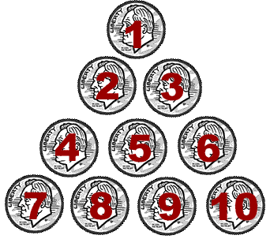
2. Ask if anyone in the room can form a NEW triangle that points down. Of course, everyone will say "Sure, that's easy!"...but then you will tell them that they can only move THREE of the pennies to do so!

Answer:
The secret to the puzzle is to move coin #7 next to coin #2. Move coin #10 next to coin #3. Center coin #1 below coins #8 and #9. Look at th picture below. Do you see how the triangle points downward once you have done this?
