The Budgeting Process - Worksheet Name: _______________________

- Kate works on salary and earns $2259.09 per month. She kept track of her monthly expenses for a period of 6 months.
Average
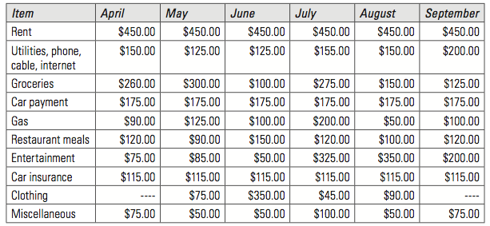
- Use this information to calculate her average monthly expenses in each category for the 6-month period.

- Create a possible conservative budget for Kate. If she has a surplus, allocate the extra money to savings.
Kate’s Monthly Budget
Income |  | Expenses
Total Income |  | Total Expenses
- Craig and Stéfanie live in Vancouver, BC. They are creating a budget to help them control their spending. Craig earns semi-monthly pay of $1400.00. Stéfanie’s semi- monthly pay is $1385.00. They have kept track of their other expenses for 4 months.
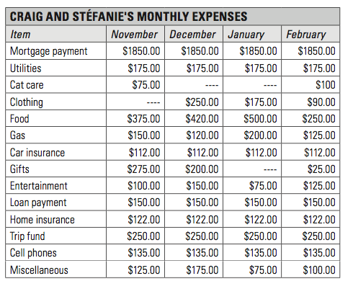
- Use their financial records to create a conservative monthly budget for Craig and Stéfanie.
Craig and Stefanie’s Monthly Budget
Income |  | Expenses
Total Income |  | Total Expenses

- If they follow this budget, how much money will they be able to save in one year?

- Janae works as a server and earns an hourly wage plus tips. She works about 40 hours per week, at a rate of $10.75 per hour. She takes home about $500.00 in tips each month. Her fixed and variable expenses account for about 80% of her income.
  - a) How much money does Janae put into savings each month? (Assume there are 4 weeks in a month.)

  - b) Janae spends about $75.00 a week on food. What percentage of her income does this represent?

  - Justin works on contract as a landscaper. He earns about $2700.00 a month. He is creating a budget and wants to put 12% of his income into savings.

- If he follows his budget, how much will he save each month?

- How long will it take him to save $1500.00?

- Veejay is saving for his college tuition. Since his parents do not charge him room and board, he plans on saving 55% of his income. If he earn $1725.00 month, how long will it take him to save the $6000.00 he needs for tuition and $550.00 for books?

- Marcel is looking for a new apartment. He works for 40 hours a week at a job that pays $14.50 an hour. He usually works 6 hours of overtime, paid at time and a half, each month. He estimates his monthly expenses as follows.
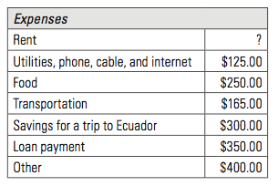
  - What is the maximum rent Marcel can pay, and still be able to afford his other expenses?

  - Marcel’s trip to Ecuador will cost about $2700.00. How many months will it take him to save up for the trip?

