14 False Advertising Scandals That Cost Brands Millions

Activia yogurt
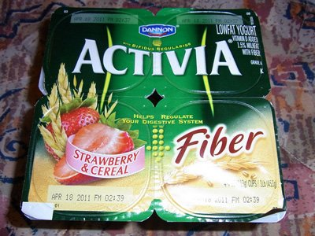
Flickr
Dannon's popular Activia brand yogurt lured consumers into paying more for its purported nutritional benefits -- when it was actually pretty much the same as every other kind of yogurt.
Falsely touting the "clinically" and "scientifically" proven nutritional benefits of the product, Dannon even got a famous spokesperson, Jamie Lee Curtis, for the supposed digestion-regulator. But after a while, some customers didn't buy it.
A class action settlement last year forced Dannon to pay up to $45 million in damages to the consumers that filed the lawsuit and others who said they'd been bamboozled. The company also had to limit its health claims on its products strictly to factual ones.
Source: ABC News

Taco Bell's seasoned beef
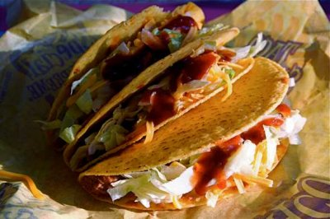
www.flickr.com
When consumers raised questions about what was actually seasoning Taco Bell's seasoned beef, the company didn't know how to respond.
It was simply using oat filler -- which means the meat isn't seasoned beef at all, according to USDA standards. The franchise had been tricking its consumers into thinking its products were of a higher grade than they actually were.
Taco Bell took the opportunity to poke fun at itself, hoping to mitigate the PR disaster. The company even took out a full-page newspaper ad thanking complainants for suing. So far, so good. Taco Bell's proactivity and willingness to address the controversy have restored some faith in the fast food giant.
The woman who started all the hullabaloo ultimately dismissed her lawsuit.
Source: Ad Age

Definity eye cream
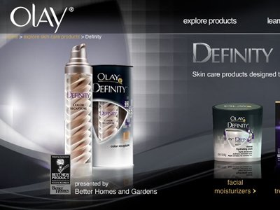
Olay
In 2009, an Olay ad for its Definity eye cream showed former model Twiggy looking wrinkle-free -- and a whole lot younger than her years (she turns 62 next week). Turns out the ads were retouched.
British lawmakers yanked digitally altered spots, citing not only a gross misrepresentation of products, but the ad's potentially negative impact on people's body images.
Source: Yahoo! Shine

Hyundai and KIA vehicles' horsepower
Screengrab from AmsterdamAdBlog on YouTube
Hundreds of car owners were extremely disappointed to find out that Hyundai and Kia overstated the horsepower in some of their vehicles.
In 2001, the Korean Ministry of Construction and Transportation uncovered the misrepresentation, which for some models was as much as 9.6 percent more horsepower than the cars actually had.
A class action lawsuit in southern California claimed the companies were able to sell more cars and charge more per vehicle because of the false claims. In the end, the auto powerhouses had to pay customers -- the settlement was estimated to be between $75 million and $125 million.
Source: GirardGibbs.com

Groupon's tourism ads
Groupon
Groupon was sued by a San Francisco-based tour company earlier this year for allegedly running misleading ads on Google. Groupon's accused of using keywords related to certain tourist attractions to trigger ads, while not actually offering coupons related to any of those attractions.
The class-action suit is currently ongoing -- it was approved by a judge in August after Groupon tried to get it dismissed.
Sources: MediaPost, AdWeek

Rice Krispies & Frosted Mini-Wheats
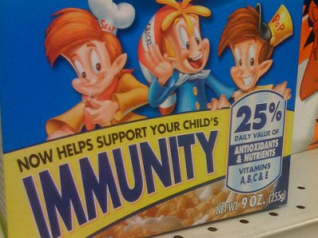
Ben+Sam on Flickr
Kellogg's popular Rice Krispies cereal had a crisis in 2010 when it was accused of misleading consumers about its immunity boosting properties. The Federal Trade Commission ordered Kellogg to halt all advertising that claimed that the cereal improved a child's immunity with "25 percent Daily Value of Antioxidants and Nutrients -- Vitamins A, B, C and E," stating the the claims were "dubious."
Just a year prior, the company settled with the FTC over charges that its Frosted Mini-Wheats cereal didn't live up to its ads. The campaign claimed that the cereal improved kids' attentiveness by nearly 20%, and was shot down when the FTC found out that the clinical studies showed that only 1-in-9 kids had that kind of improvement -- and half the kids weren't affected at all.
Source: CNN

Airborne
By welivefast on Flickr
Herbal supplement Airborne was a national hit throughout the 1990s. Marketing of the product claimed that it helped ward off harmful bacteria and germs, preventing everyday ailments like the flu and common cold. But did Airborne actually have these benefits?
Apparently not, which sparked a huge false advertising scandal. There were no studies to support Airborne's effectiveness that met scientific standards -- so the Center for Science in the Public Interest (CSPI) got involved.
The high-profile scandal ended with a huge settlement, with Airborne having to pay $23.3 million in the class-action lawsuit, and an additional $7 million settlement later. The exact benefits to users of Airborne remain unestablished.
Source: NPR

Extenze
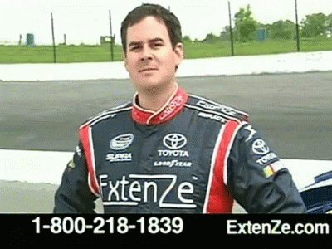
ExtenZe infomercial via YouTube
Extenze has claimed to be "scientifically proven to increase the size of a certain part of the male body."
But in 2010, the company had to pay a $6 million settlement to disappointed, less-endowed men everywhere.
Source: BNET

Splenda
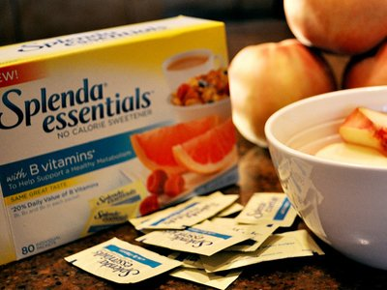
By GoodNCrazy on Flickr
The Sugar Association says Splenda's "Made from Sugar" slogan is misleading, and that the sweetner is nothing more than "highly processed chemical compound made in a factory," reports CBS.
In 2008, the association first filed a suit against Johnson & Johnson subsidiary McNeil Nutritionals, which then countersued the association engaging in a "malicious smear campaign." The two parties reached a confidential settlement before going to trial.
Equal also took its rival to court in 2007, accusing "the makers of Splenda of confusing consumers into thinking its product was healthier and more natural than other artificial sweeteners." The two parties also reached a confidential settlement.

Pennzoil
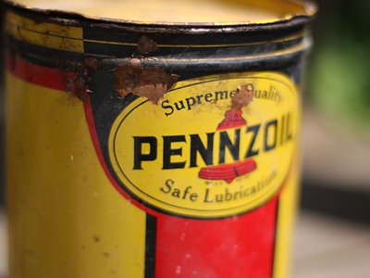
By eflon on Flickr
Pennzoil was ordered to pull ads that showed their oil performing better than their competitors after a New Jersey judge called them "false and misleading" and "repugnant." Houston-based Pennzoil was claiming superiority over four different brands, including New Jersey-based Castrol. Pennzoil is no longer allowed to claim that their oil is better at protecting car engines than Castrol.
Brett Favre is shown in the television and internet ads, using Pennzoil as face paint before the big game.
Source: Houston Chronicle

New Balance
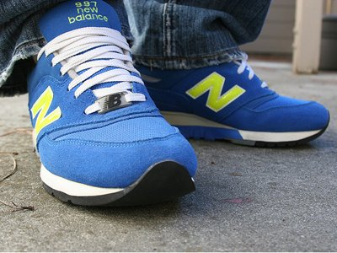
By sling@flickr on Flickr
A New Balance sneaker that reportedly helped users burn calories were called out when studies did not find any boosted health benefits from wearing the shoe.
The toning sneaker, claimed to use hidden board technology, were advertised as calorie burners that activated the glutes, quads, hamstrings and calves. Plaintiffs discovered that the shoe was instead an injury hazard, without any secret technology, and are seeking $5 million in compensation. The sneakers cost about $100.
Source: Reuters

Kashi
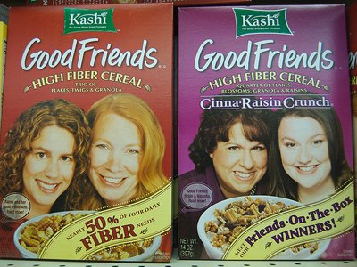
By alexstaubo on Flickr
Despite claims to the contrary, Kashi Company's "All Natural" products were chock full of "almost entirely synthetic and unnaturally processed ingredients," according to to the class action lawsuit filed against them. In fact, ingredients that are considered prescription drugs and federally-classified hazardous substances were found to be the primary ingredients in the so called "natural" foods.
The lawsuit, on behalf a proposed class of all U.S. consumers, says that Kashi put the all-natural labels on their foods even though they knew the claim to be false. For example, Kashi GoLean shakes are composed almost entirely of unnatural processed ingredients.
Source: Top Class Actions

Eclipse gum
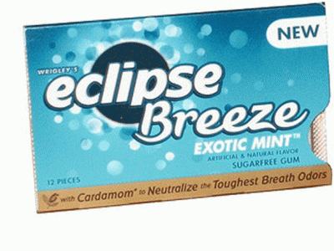
the impuslivebuy via flickr
Eclipse gum claimed that its new ingredient, magnolia bark extract, had germ-killing properties. Businessweek reports:
Consumers sued Wrigley [in 2009] in federal court arguing the subsidiary of privately held Mars Inc. made misleading advertising claims about the germ-killing properties of Eclipse.
As part of the settlement, Wrigley will change how it markets and labels its gum. It agreed to pay $6 million to $7 million to a fund that will reimburse consumers up to $10 each for the product and cover other costs of the settlement, according to the law firms Blood Hurst & O'Reardon and Robbins Geller Rudman & Dowd.

Classmates.com
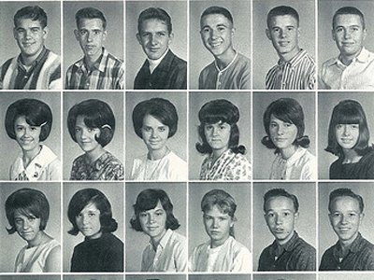
By Small Town OK on Flickr
Millions of people lit up when Classmates.com sent them an email saying old friends were trying to contact them, promising to rekindle old friendships and flames if subscribers upgraded to a "Gold" membership.
But even with an upgrade, the expected reunions never came. Turns out the social networking site used the ploy to get users to pony up extra dollars. In 2008, one miffed user filed suit alleging the "deceptive" emails were false advertising.
He eventually bested the website, which agreed to pay out a $9.5 million settlement -- $3 for every subscriber who fell for the dirty trick -- to resolve the case.
Source: Mashable

