Static Equilibrium Review F_{net} = 0!

Condition #1: Translational Equilibrium - Any object that has zero net force acting on it is in a state of equilibrium. In this sense, equilibrium is the property of an object experiencing no acceleration. The object can be at rest (static equilibrium) or moving at a constant velocity (dynamic equilibrium).

Condition #2: Rotational Equilibrium
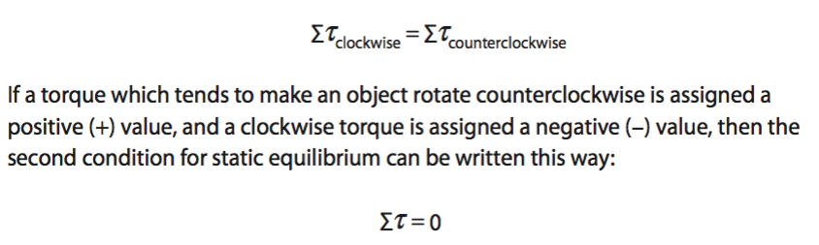
Questions:
- The heavy pendulum is held motionless by the force on the horizontal rope.  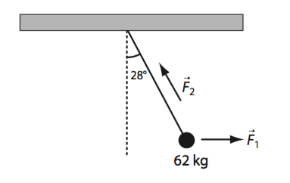  Calculate:  - The intension in horizontal the rope  - The tension in the rope supporting the pendulum at 28º to the vertical | - The two ropes in the diagram below support the 500.0 N load between them, but the act at different angles?  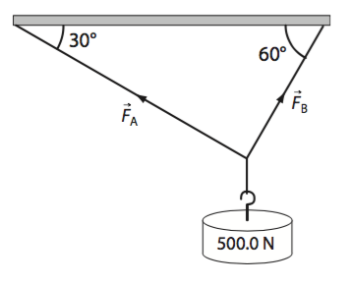  Calculate:  - What must the resultant of the two tension forces in the ropes?  - What is the magnitude and direction of the tension in each of the two ropes?
- Two rugby players pull on a ball in the directions shown in the diagram below. What is the magnitude of the force that must be exerted by a third player to achieve translational equilibrium on the ball?  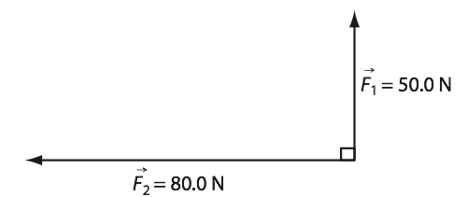 | - A 588 N mother sits on one side of a seesaw, 2.20 m from the pivot. Her daughter sits 2.00 m from the pivot on the other side of the seesaw. If the force of gravity on this child is 256 N, where must the mother’s other child sit to balance the seesaw if the force of gravity on him is 412 N?

- What upward force is exerted by the right support leg of the bench in the drawing below?  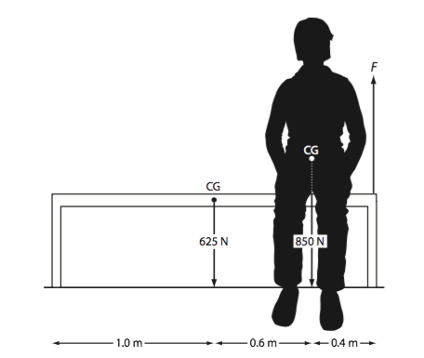 | - If the force of gravity on the beam in the diagram below is 1.2 x 10³ N, what forces must be exerted at A and B to maintain equilibrium? In what direction must the force act?  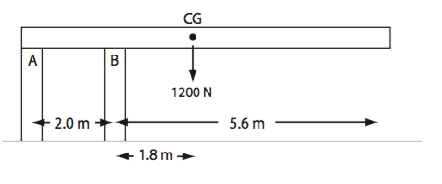
- If the force exerted by the fish line on the tip of the rod is 4.0 N, what force must the person fishing exert in the direction and location shown in the drawing below? Ignore the rod’s mass, and assume the rod is pivoted in the other hand.  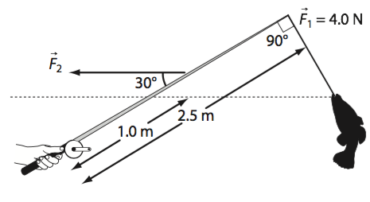 | - A uniform 15 kg ladder that is 5.0 m long stands on the floor and leans against a vertical wall, making an angle of 25º with the vertical. If the friction between the ladder and the wall is negligible, what is the minimum amount of friction between the ladder and the floor will keep the ladder from slipping?

