Solution Chemistry Notes Name: ______________________

Definitions:

Solution:

Solvent:

Solute:

Saturated:

Unsaturated:

Solubility:

Bonding Reminder – Two Extremes
Covalent - “Sharing” | Ionic – “Not-Sharing”
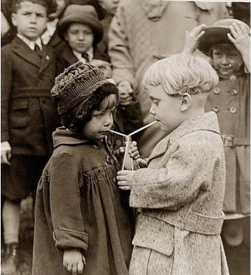

Van der Waals Forces:

THREE main types:

DIPOLE-DIPOLE FORCES

Dipole: δ⁺ Cl—F δ⁻

- *a permanent dipole results from atoms with different ___________________________
- Dipole-Dipole Forces:

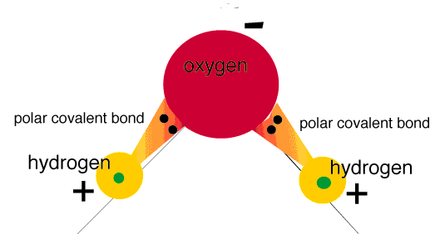

MOLECULAR POLARITY

Polar: Difference in Charge Distribution

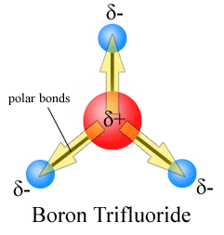

Nonpolar: Either no difference, or difference cancels our

One of the following does NOT hold

Ex: Which of the following are expected to be polar and which are expected to be nonpolar??

LONDON FORCES

London Forces:

Only for Non-Polar molecules! *if a permanent dipole is ABSENT….LONDON FORCES!

IONIC BOND DIPOLE – DIPOLE ==LONDON FORCE

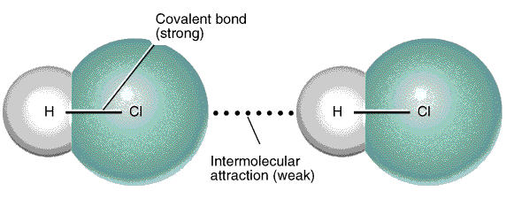

Intramolecular Intermolecular

*the attraction between polar molecules is _______________________ than the attraction between ions

*polar molecules have a higher ___________________________ then nonpolar

HYDROGEN BONDING

Hydrogen Bond:

Really the same thing as dipole-dipole interactions… just given a special name

*intermolecular bond – inter = ___________________________________

- *intramolecular bond – intra = ___________________________________

*strongest van der Waals bonds – but still weaker than _________________________

BOND TYPE | WHAT TO LOOK FOR...
INTRAMOLECULAR BONDS:
Bonds within a molecule
IONIC BOND
COVALENT BOND
INTERMOLECULAR BONDS:
Bonds between molecules/ions
HYDROGEN BOND
DIPOLE-DIPOLE FORCE
LONDON FORCE

POLAR AND NONPOLAR SOLVENTS

Dissolving Process – 3 ATTRACTIONS:

attraction of ___________________________ to surrounding ____________________________

attraction of ___________________________ to particles of ______________________________

attraction of one ______________________________ to other ____________________________

**WATER is one of the most polar solvents known and tends to dissolve both polar and ionic solutes.

Remember “Like dissolves Like”

THE NATURE OF SOLUTIONS OF IONS

The formation of a solution depends on the ability of the solute to dissolve in the solvent.

SOLVATION:

IONIC SOLID:

MOLECULAR SOLID:

DISSOCIATION:

ex:

http://www.northland.cc.mn.us/biology/biology1111/animations/dissolve.html

IONIZATION:

ex: CH₃COOH + H₂O ------> CH₃COO⁻ + H₃O ⁺

Writing Dissociation Equations

Writing dissociation equations is similar to balancing equations…

The difference is it’s always one molecule breaking into the ions that make it up

Use these rules to help you balance Dissociation Equations

The state is VERY important (aq)

Same rules for balancing Elements as before

PLUS we must now balance the charge (same amount of charge on the Left Side as Right Side

The [ions] released is proportional to the ratio of elements in the original molecule

THE CONDUCTIVITY OF AQUEOUS SOLUTIONS

A conducting solution contains ions; ____________________________________________________________________

A compound made up of a METAL and NONMETAL is __________________________________________________

A substance made up of a NONMETAL and a NONMETAL is ____________________________________________

**TO CONDUCT or NOT CONDUCT??? that is the question.....

CONDUCT DOESN’T CONDUCT

- ionic - solid

- acidic - covalent

- basic - starts with C

- CH₃COOH (exception)

