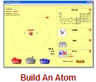**Build An Atom PhET Lab SOLUTIONS**

**Introduction:** Atoms are the smallest things that retain the properties of matter we can observe. Atoms are made of three ***subatomic*** particles; protons, neutrons, and electrons.

* Protons have a mass of ______________________.
* 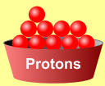Neutrons have a mass of ______________________.
* Electrons have a mass of nearly______________________.

*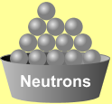In this simulation, you will build atoms, subatomic particle by subatomic particle and observe the effect of adding more of each particle. When the subatomic particles in an atom change, an* ***ion****,* ***isotope*** *or different element will be created.*

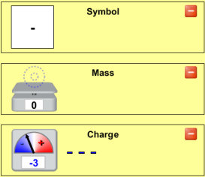**Procedure:** *Play with the Sims 🡪 Chemistry 🡪 Build An Atom* 

Begin by playing with the simulation for a while. Become familiar with the interface. What happens when you add protons, neutrons, or electrons? To start over, click .

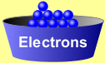Show the **symbol**, **atomic mass**, and **charge** by clicking on the .

**Analysis Questions**

1. Ions are atoms of the same element with different numbers of _______________________________.
2. Isotopes are atoms of the same element with different numbers of __________________________________.
3. Adding or removing protons from an atom does what to the atom? _______*___________________________.*
4. An atom with the same number of protons and electrons has a charge of ________.
5. Adding two electrons to a neutral atom produces an ion with a charge of ________.
6. An atom with six protons and five electrons would have a charge of ________.
7. What atom is created with nine protons, nine neutrons, and nine electrons? ***___________________***



1. Show the full symbol for the above atom in the box at the right
2. What does the upper-left number in the symbol represent? _*__________________*_
3. What does the lower-left number in the symbol represent? ____________________
4. Draw the atoms described below, showing protons, neutrons, and electrons:

**Hydrogen**: H **Carbon**: C **Oxygen**: O **Neon**: Ne

|  |  |  |  |
| --- | --- | --- | --- |
|  |  |  |  |

**The Game**

With remaining class time, play a few games. Who in your lab group can get the highest score? WINNER: _______________

***Complete the table below***

Remember…when there are more electrons than protons, the charge should be: _________.

And when there are more protons than electrons, the charge will be: _______________.

|  |  |  |  |  |  |  |  |
| --- | --- | --- | --- | --- | --- | --- | --- |
| Protons | Neutrons | Electrons | Atomic Number | Mass Number | Charge | Element | **Full** Symbol |
| **4** | **4** | **4** | **4** | **8** | **0** | **Be** |  |
| **5** | **5** | **6** | 1. | 2. | 3. | 4. |  |
| **8** | **8** | **7** | 6. | 7. | 8. | 9. |  |
| 11. | 12. | 13. | **7** | **13** | **-3** | 14. |  |
| 16. | 17. | 18. | **9** | **20** | **-1** | 19. |  |

**Conclusion Questions (use a periodic table)**

1. All Zinc atoms have (how many?) ______ protons.
2. If a Copper atom has no charge (neutral), it would contain (how many?) _______ electrons.
3. All atoms that have 14 protons are (what element?) _______.
4. If an atom of Zinc has a mass of 64, it has (how many?) ________ neutrons.
5. Silver-108 has a mass of 108. This means that it would have (how many?) ______ neutrons with its 47 protons.
6. (Sodium) has (how many?) _____ protons and (how many?) _____ neutrons for a total mass of 23.
7. A -1 ion of Bromine would have _____ protons and _____ electrons.
8. A +2 ion of Calcium would have _____ protons and _____ electrons.
9. To form an ion with a -2 charge, an atom of Sulfur would need to have _____ electrons.
10. A neutral atom of Zinc-66 has _____ protons, _____ neutrons, and _____ electrons.