**Module 4 – SHM: Quiz 3b**

1. The simple pendulum shown below is initially held in place by a horizontal rope, making a 42o angle to the vertical. The mass of the pendulum is 15 kg, its length is 2.5 m, and it is attached to a point that is 5.2 m above the floor. ***Answer the following questions about the pendulum.***

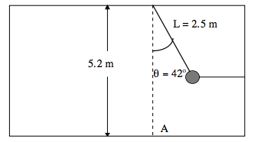

* 1. Determine the tension in the horizontal rope.

***The horizontal rope is cut from the pendulum and it starts to oscillate in simple harmonic motion.***

* 1. Find the frequency of the pendulum
  2. Determine the pendulum’s maximum velocity.
  3. Find the tension in the pendulum’s string when it is at the lowest point in its swing.

Answers:



