Module 4 – SHM: Quiz 3a

- Describe the effects on the period of motion when the pendulum's mass is tripled.

- By what factor has the acceleration changed due to gravity if the length is doubled and the period has changed by a factor of 5?

- A string with a bowling ball tied to its end is attached to the ceiling. The string is pulled back such that it makes a 10° angle with the vertical, and it is then released. When the bowling ball reaches its lowest point, it has a speed of 2 m/s. What is the frequency of this bowling ball-pendulum?
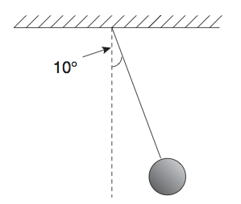

Answers:

- No Effect
- 2/25 (0.08)
- 