**Module 4 – SHM: Quiz 2b**

1. A child’s Nerf gun toy is “souped up” by replacing the spring. The spring’s force constant is 1000 N/m now. The spring is compressed by the Nerf dart 10 cm. What force is required to compress the spring in the gun?
2. A 3 kg block is fastened to a vertical spring that has a spring constant of 800 N/m. A 1.2 kg block rests on top of the 3 kg block, as shown below.

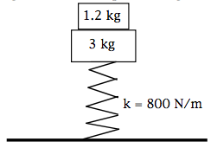

1. When the blocks are at rest, how much is the spring compressed from its uncompressed length?
2. The blocks are now pushed down so that they oscillate. Determine the frequency of the oscillation.
3. Determine the magnitude of the acceleration that the blocks can attain and still remain in contact at all times.

Answers:



1. 
2. See below.

