**Module 4 – SHM: Quiz 1a**

1. Use the picture of a wave below to answer the following questions, note one or more of the questions might not be solvable!
   1. 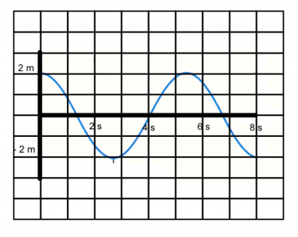What is the amplitude?
   2. What is the period?
   3. What is the wavelength?
   4. What is the frequency?
2. In an engine, a piston oscillates with SHM according to:

x(t) = 5cos(2t + π/6)

where x is in cm and t is in second. At time t = 0 seconds find the position, velocity and acceleration of the motion. ***Also determine the period!***

Answers:



1. Answers Below
   1. Amplitude = 2 m
   2. Period ~ 5.25 s
   3. UNKNOWN – Can’t solve with given info
   4. Frequency ~ 0.19 s-1
2. Remember to put your calculator in Radians!
   1. 
   2. 
   3. 



* 1. f = π-1 Hz therefore P = π seconds