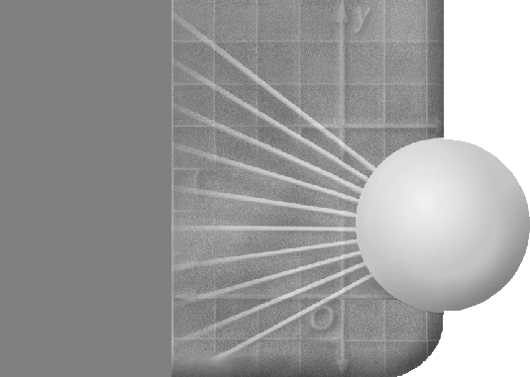
Group Name: ______________________________________________ DATE ____________

Surface Area of a Robot

Meet Robby the Giant Robot. You’re task is to determine his TOTAL surface area (Area exposed).

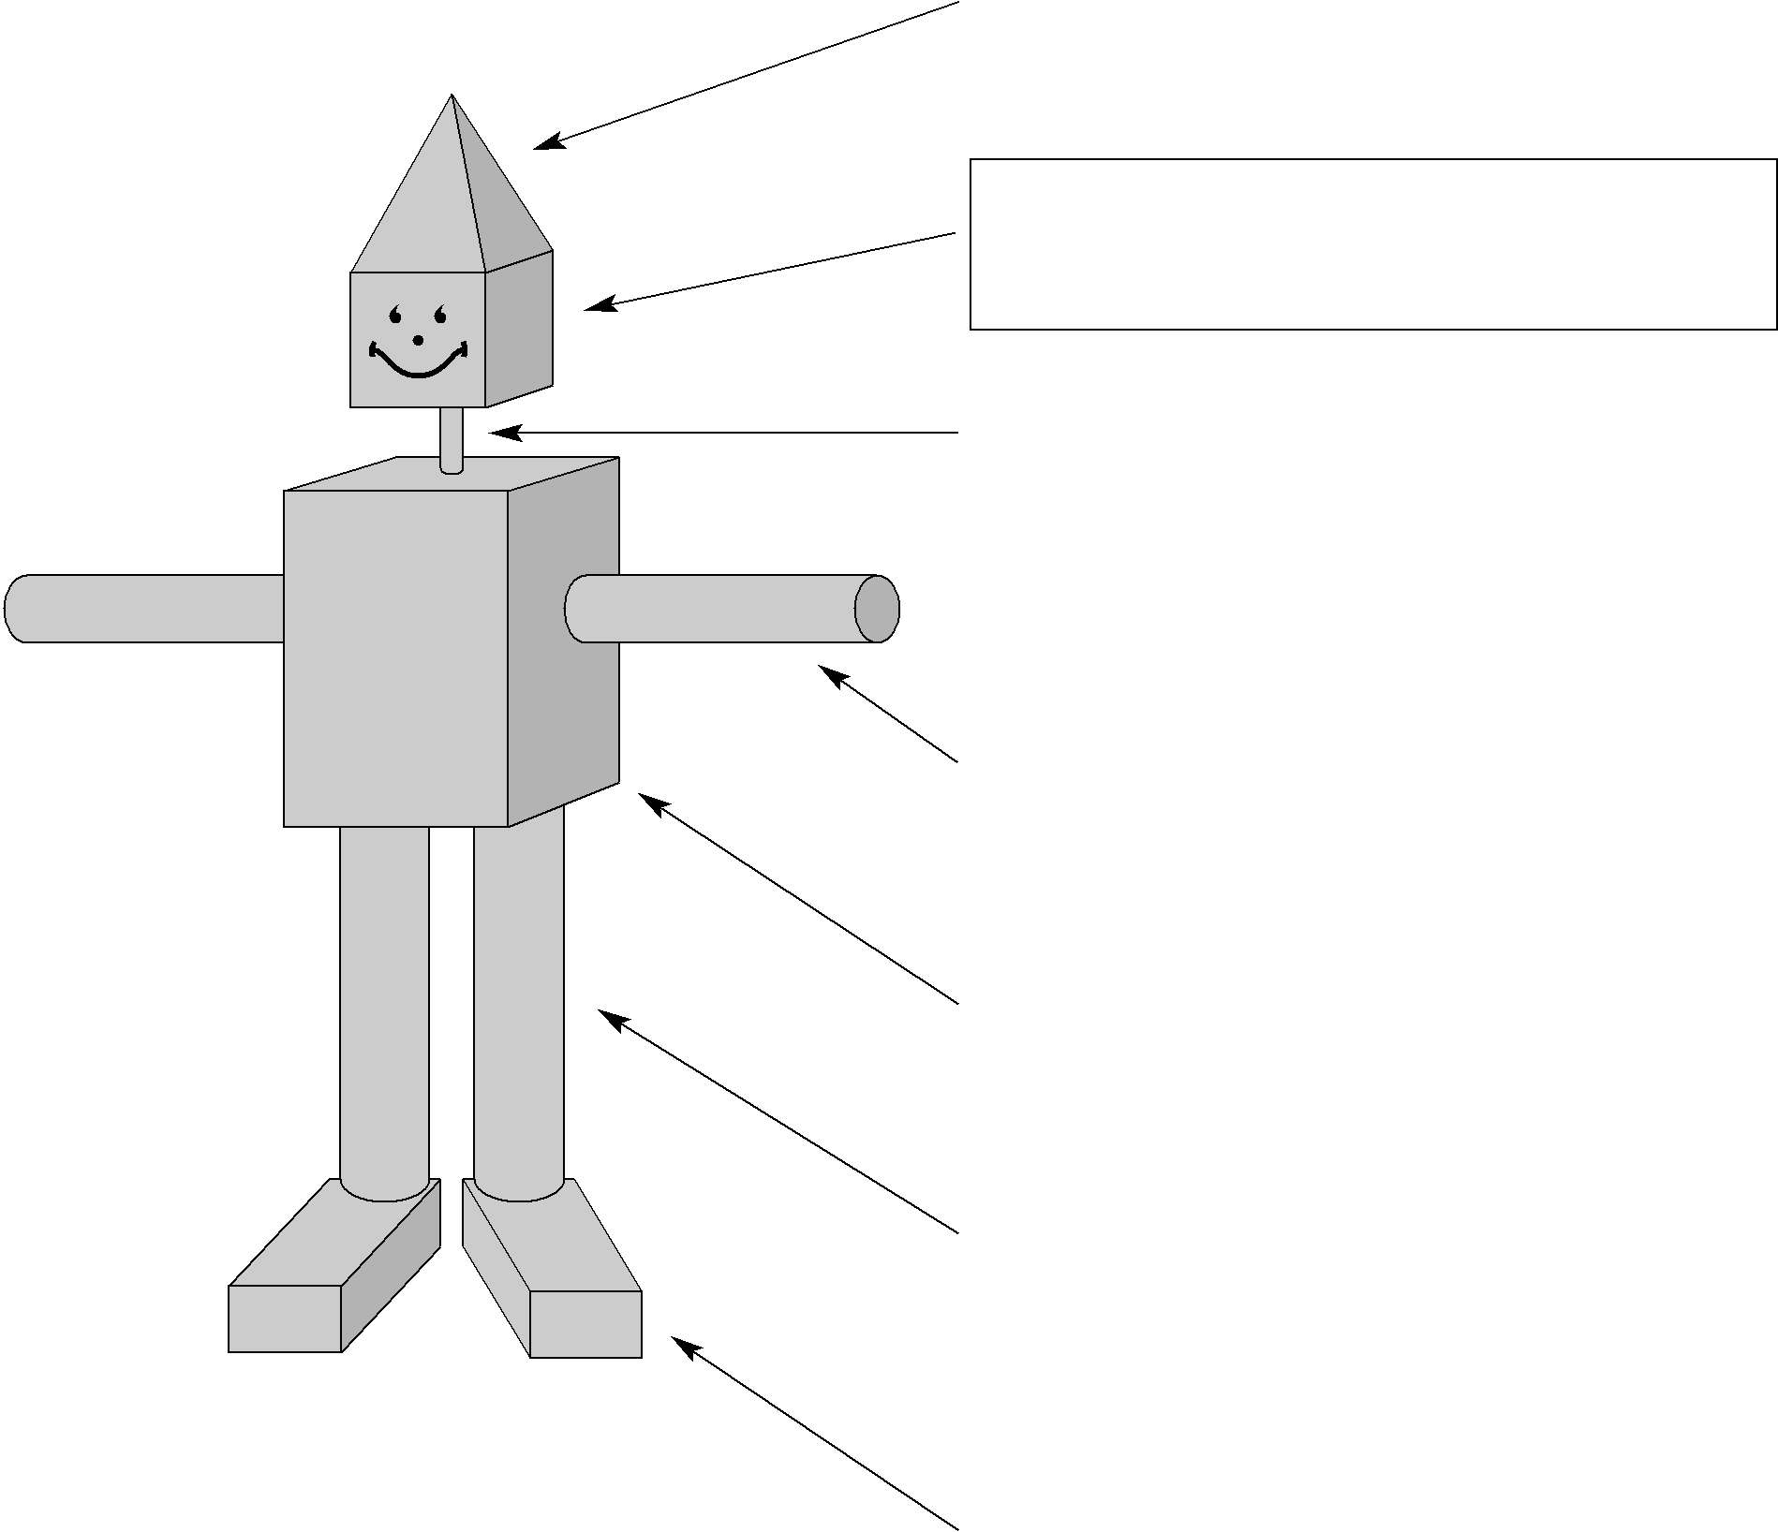
The hat is a square pyramid. Each side of the base is 6 m long, the height of the pyramid is 8 m, and a slant height of 8.5 m. What is the Surface of the hat?
The head is a cube. Each side of the cube is 6 m long. Find the Surface Area of the head.

The neck is a cylinder. The radius of the base is 1 m and the height of the cylinder is 3 m. What is the Surface Area of the neck to the nearest whole number.

Cylinders are used for the arms. The diameter of each arm is 3m and the length of each arm is 15 m.

Find the Surface Area of one arm to the nearest whole number.

The torso is a rectangular prism. The dimensions of the body are 10 m by 10 m by 15 m. What is the Surface Area of the torso?

Cylinders are used for the legs. Each leg is 4 m in diameter and 18 m long. Find the Surface Area of one leg to the nearest whole number.

Rectangular prisms are used for feet.

Each foot is 5 m by 3 m by 6 m.

What is the Surface Area of each foot?

What is the total Surface Area of the robot? (Show ALL you work on separate piece of paper)

Hints:

- Break Robby down into 2D shapes (don’t forget the shapes facing into the page!)
- Minus the 2D shapes that are covered by other shapes
- Find the Surface Area of each 3D shape
- Add the Surface Area of all the 3D shapes together to find Robby’s total Surface Area

