Chemistry 11 - Atomic Theory, Periodic Table, and Bonding Theory Review

1. Give the number of protons, neutrons and electrons in the following:

|  |  |  |  |
| --- | --- | --- | --- |
| *Isotope* | *Protons* | *Neutrons* | *Electrons* |
| 177Hf 3+ |  |  |  |
| 209Po 2+ |  |  |  |
| 212At - |  |  |  |

1. Give the nuclear notation of the following:

|  |  |  |  |
| --- | --- | --- | --- |
| *Isotope* | *Protons* | *Neutrons* | *Electrons* |
|  | 42 | 54 | 39 |
|  | 32 | 42 | 32 |
|  | 108 | 157 | 105 |

1. What is the name of the element, **X**, which has the following mixture of isotopes:   
   192X = 35.5%, 194X = 34.9%, 198X = 20.3%, 209X = 9.3%
2. Each single orbital can hold a maximum of _________ electrons.
3. An “s” subshell (1 orbital) can hold a maximum of ____ electrons   
    A “p” subshell (3 orbitals) can hold a maximum of ____ electrons   
    A “d” subshell (5 orbitals) can hold a maximum of ____ electrons   
    An “f” subshell (7 orbitals) can hold a maximum of ____ electrons

When electrons in an atom are filling energy levels, they fill the _______________ possible energy levels first.

1. Give the electron configuration for each of the following atoms and ions: (You may use core notation )

|  |  |
| --- | --- |
| Si | Cr |
| Br | Sr |
| K | Fe |
| Ge | P |
| Na+ | Mg+2 |
| Br- | As-2 |
| O-2 | Te-2 |

1. Write the configuration and then find the number of valence electrons for the following atoms:   
     
   N (configuration) _____________________________________ (# of valence e-‘s) _______  
     
   Si (configuration) _____________________________________ (# of valence e-‘s) _______  
     
   Ca (configuration) ____________________________________ (# of valence e-‘s) _______  
     
   P (configuration) _____________________________________ (# of valence e-‘s) _______  
     
   Al (configuration) ____________________________________ (# of valence e-‘s) _______

**On the following diagram of the Periodic Table, list the number of valence  
electrons and the most common ion charge in Groups 1,2 & 13-18**

# of Valence e-s __ __ __ __ __ __ __ __

Ion Charge __ __ __ __ __ __ __ __

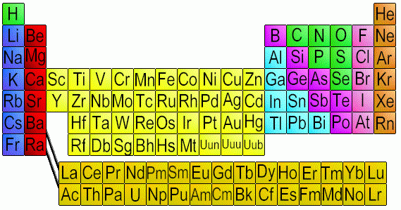

1. In order to become stable,

an atom of Ca will _donate__ _2_ electrons and become the ion __Ca2+___  
  
an atom of Se will __________ ___ electrons and become the ion ________

an atom of K will __________ ___ electrons and become the ion ________

an atom of Br will __________ ___ electrons and become the ion ________

an atom of N will __________ ___ electrons and become the ion ________

an atom of As will __________ ___ electrons and become the ion ________

an atom of Al will __________ ___ electrons and become the ion ________

an atom of Te will __________ ___ electrons and become the ion ________

1. What is the general trend in atomic radius (size of atoms) as you move from left to right across any Period? (*increase/decrease*) _______________________________
2. As you move from Li to Ne, electrons are filling (*the same/different*) ______________ energy levels(s). This may help explain why atoms *don’t* get bigger as you move to the right within a period.
3. As you move across from Li to Ne, what is happening to the number of *protons* in the nucleus? ________________________. What do the protons do to the electrons? _________________. Suggest a reason why the atoms in a period actually get *smaller* as you move from left to right.
4. What is the general trend in atomic radius (size of atoms) as you move *down* a vertical column (group)? (*increase/decrease*) ________________________________
5. Suggest a reason for this trend. (*Hint: are electrons filling up the same energy level (orbitals) as you move down a column?*)
6. What is meant by **ionization energy**? ___________________________________________________________
7. What is the general trend in first ionization energy as you move from left to right across any Period? (eg. from Li🡪Ne or from Na🡪Ar) (*increase/decrease*) ____________________
8. Keeping in mind the trend in atomic radius as you move from left to right across a period, suggest a reason for this trend in ionization energies. (Hint: *What happens to the distance and the force of attraction between the nucleus and the outer electron as atoms get smaller?*)
9. What is the trend in ionization energy as you move down a vertical column, like from Li🡪Na🡪K or from He🡪Ne🡪Ar🡪Kr? (*increase/decrease*) __________________________

Suggest a reason for this trend based on atomic radius (size) and the distance and force of attraction between the nucleus and the outer electron.

1. Compare the following particles:

Fluorine atom

Magnesium atom

sodium ion

oxide

neon

a. Arrange the particles using **chemical formulas** from **smallest atomic radii** to **largest atomic radii**:

b. On your answer above, using **arrows** show the trend of **electronegativity, ionization energy** and **electron affinity**.

Draw Lewis Structures (Electron-dot diagrams) for the following ionic compounds:

|  |  |
| --- | --- |
| a) CaF2 | b) AlF3 |

1. Draw Lewis Structures (Electron-dot diagrams) for the following covalent compounds.

a) NH3 b) ClF4+  
  
  
  
  
  
  
c) NO3- d) PF3

e) CH3CH2CH3 f) N2Br4

g) H2S h) SeCl2

i) BH2- j) SF5-