**Unit 6: Quiz 7b**

/5

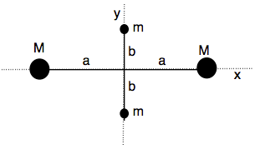

Four point masses are fastened to the corners of a frame of negligible mass lying in the xy plane as shown to the right.

1. If the rotation of the system occurs ***about the y-axis*** with an angular speed ω, find the moment of inertia about the y-axis.
2. Calculate the rotational kinetic energy ***about the y-axis***.
3. Suppose the system rotates in the xy plane about an axis through the z-axis. ***The z-axis goes in and out of the page***. Calculate the moment of inertia ***about the z-axis***.
4. Calculate the rotational EK about the z-axis.



Four point masses are fastened to the corners of a frame of negligible mass lying in the xy plane as shown to the right.

1. If the rotation of the system occurs ***about the y-axis*** with an angular speed ω, find the moment of inertia about the y-axis.



1. Calculate the rotational kinetic energy ***about the y-axis***.



1. Suppose the system rotates in the xy plane about an axis through the z-axis. ***The z-axis goes in and out of the page***. Calculate the moment of inertia ***about the z-axis***.



1. Calculate the rotational EK about the z-axis.



