**Unit 6: Quiz 6b**

/5

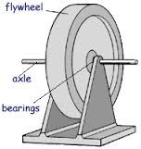

A 1.20 m diameter flywheel is rotating *clockwise* at 215 rpm.

1. What is the linear speed ***(in m/s)*** of a point on the rim of the flywheel?
2. What constant angular acceleration will cause the wheel to increase its speed to 915 rpm in 60.0 s?
3. Through what linear distance ***(in m’s)*** does the outer point of the wheel travel during the 60.0 s interval?

A 1.20 m diameter flywheel is rotating *clockwise* at 215 rpm.

1. What is the linear speed ***(in m/s)*** of a point on the rim of the flywheel?



1. What constant angular acceleration will cause the wheel to increase its speed to 915 rpm in 60.0 s?



1. Through what linear distance ***(in m’s)*** does the outer point of the wheel travel during the 60.0 s interval?

