**Quiz 4C**

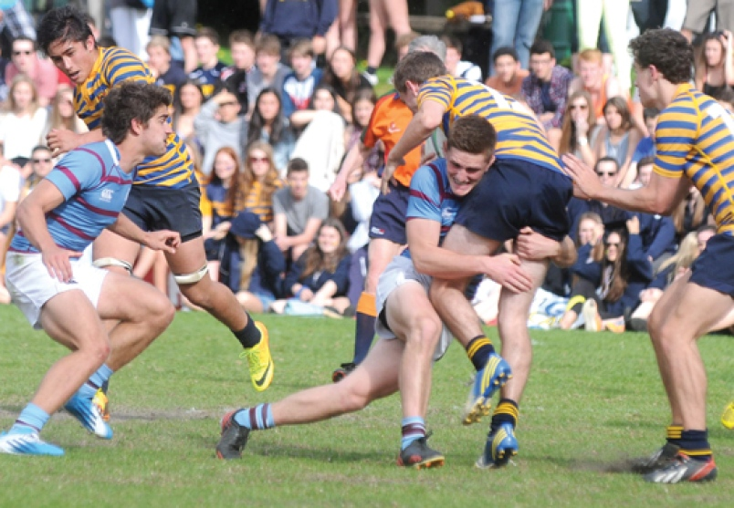A Collingwood rugby player is running 4.2 ***m/s north*** (thinking he is about to score a try) when a Rockridge player comes out of no where, and decleats him (***tackles him***) into the ***east sideline.*** At the instant ***after*** the tackle the Collingwood player is traveling at a speed of ***6.3 m/s east.*** What is the Collingwood players change in velocity?

Quiz 4C

A Collingwood rugby player is running at ***4.2 m/s north*** (thinking he is about to score a try) when a Rockridge player comes out of no where, and decleats him (***tackles him***) into the ***east sideline.*** At the instant ***after*** the tackle the Collingwood player is traveling at a speed of ***6.3 m/s east.*** What is the Collingwood players change in velocity?



vf

-vi

Δv

