An Algebra Tiles Art Project
Over Chapters 5 & 7, we have covered how to add, subtract, multiply and divide different types of polynomials.
We’ve learned about degrees of polynomials.
We’ve learned about monomials, binomials, trinomials & polynomials.
We have also learned about algebra tiles and how to determine all of the above using them.
COLOURED = POSITIVE WHITE = NEGATIVE
-XY
-Y
-Y²
-X²
-X
XY
Y²
X
Y
X²

-1
1
Step 1: Designing Your Art
You will design a picture using algebra tiles.
You will make a picture that incorporates both positive and negative terms.
You may change the colours of the tiles, but you must include a LEGEND to indicate what the different colours mean. For example:
Legend
Green = X tiles
Blue = Y tiles
Pink = -X tiles
Have a look at the following for some inspiration!
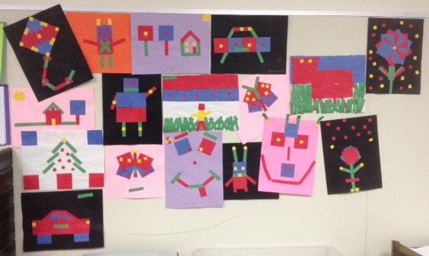

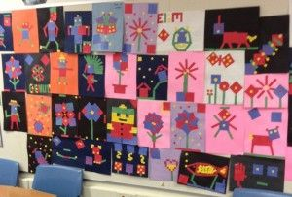
So think about a design you
want to use and make it!

Step 1: Your Masterpiece Goes Here…

Step 2: Adding & Subtracting with Polynomials
YOU MUST DRAW A LINE THROUGH YOUR ART WORK THAT DIVIDES YOUR ART WORK INTO TWO SECTIONS.
For example, in the following picture, the picture divides the ‘tree’ from the ‘koala’.
A
B
Label one section as ‘A’ and the other as ‘B’.
In the following sections, you are going to ADD A and B
together where indicated and then you will SUBTRACT
them.
CLEARLY show your addition and subtraction using
sketched algebra tiles AND using algebra.
ADD A+ B
Section A Section B Result
Visually

Algebraically

SUBTRACT A - B
Section A Section B Result
Visually

Algebraically

Step 3: Multiplying & Dividing with Polynomials
You must create and answer the following types of questions using algebra tiles from your art piece. You will show your questions and results algebraically and visually.
MULTIPLYING
A monomial with a monomial Ex: 3x(4y)
Visually
Algebraically

A monomial with a binomial that contains a negative Ex: 3x(-2 + x)
or 3x(x – 2)

A binomial with a binomial Ex: (x-4)(x-3)

DIVIDING
A monomial with a monomial. Ex: 12xy / 3x

A binomial with a monomial. Ex: (6y – 2xy) / 2y

Self-Assessment:
When your project is complete, self-assess yourself on the following rubric.
Criterion C: Communicating
(0) | Beginning (1-2) | Developing (3-4) | Accomplished (5-6) | Exemplary (7-8)
I have not achieved a standard described by any of the descriptors to the right. | I am able to:  use limited mathematical language  use limited forms of mathematical representation to present information  communicate through lines of reasoning that are difficult to interpret. | I am able to:  use some appropriate mathematical language  use appropriate forms of mathematical representation to present information adequately  communicate through lines of reasoning that are complete  adequately organize information using a logical structure. | I am able to:  usually use appropriate mathematical language  usually use appropriate forms of mathematical representation to present information correctly  usually move between different forms of mathematical representation  communicate through lines of reasoning that are complete and coherent  present work that is usually organized using a logical structure. | I am able to:  consistently use appropriate mathematical language  use appropriate forms of mathematical representation to consistently present information correctly  move effectively between different forms of mathematical representation  communicate through lines of reasoning that are complete, coherent and concise  present work that is consistently organized using a logical structure.
What a complete assignment looks like:
You develop an art piece that contains a variety of algebra tiles – both x & y and +/-. You have a legend that clearly indicates the different colours and their meaning.
Your questions and answers (both algebraic and visual) are clear and easy-to-follow.
Criterion D: Applying Mathematics in Real-Life Contexts
(0) | Beginning (1-2) | Developing (3-4) | Accomplished (5-6) | Exemplary (7-8)
I have not achieved a standard described by any of the descriptors to the right. | I am able to:  identify few of the elements of the authentic real-life situation  apply mathematical strategies to find a solution to the authentic real-life situation, with limited success. | I am able to:  Identify some of the relevant elements of the authentic real-life situation  apply mathematical strategies to reach a solution to the authentic real-life situation | I am able to:  identify most of the relevant elements of the authentic real-life situation  apply the selected mathematical strategies to reach a valid solution to the authentic real-life situation | I am able to:  identify all of the relevant elements of the authentic real-life situation  apply the selected mathematical strategies to reach a correct solution to the authentic real-life situation
What a complete assignment looks like:
You use your art piece and select an appropriate combination of tiles to satisfy requirements when designing questions.
You use a variety of tile types (both x & y and +/-). You don’t just develop easy questions from your tiles.
You effectively, correctly and clearly use algebra tiles to model addition, subtraction, multiplication and division.
Teacher Assessment:
Mathematics Assessment Criteria for MYP Year 4 – Grade 9
Criterion C: Communicating
(0) | Beginning (1-2) | Developing (3-4) | Accomplished (5-6) | Exemplary (7-8)
I have not achieved a standard described by any of the descriptors to the right. | I am able to:  use limited mathematical language  use limited forms of mathematical representation to present information  communicate through lines of reasoning that are difficult to interpret. | I am able to:  use some appropriate mathematical language  use appropriate forms of mathematical representation to present information adequately  communicate through lines of reasoning that are complete  adequately organize information using a logical structure. | I am able to:  usually use appropriate mathematical language  usually use appropriate forms of mathematical representation to present information correctly  usually move between different forms of mathematical representation  communicate through lines of reasoning that are complete and coherent  present work that is usually organized using a logical structure. | I am able to:  consistently use appropriate mathematical language  use appropriate forms of mathematical representation to consistently present information correctly  move effectively between different forms of mathematical representation  communicate through lines of reasoning that are complete, coherent and concise  present work that is consistently organized using a logical structure.
Criterion D: Applying Mathematics in Real-Life Contexts
(0) | Beginning (1-2) | Developing (3-4) | Accomplished (5-6) | Exemplary (7-8)
I have not achieved a standard described by any of the descriptors to the right. | I am able to:  identify few of the elements of the authentic real-life situation  apply mathematical strategies to find a solution to the authentic real-life situation, with limited success. | I am able to:  Identify some of the relevant elements of the authentic real-life situation  apply mathematical strategies to reach a solution to the authentic real-life situation | I am able to:  identify most of the relevant elements of the authentic real-life situation  apply the selected mathematical strategies to reach a valid solution to the authentic real-life situation | I am able to:  identify all of the relevant elements of the authentic real-life situation  apply the selected mathematical strategies to reach a correct solution to the authentic real-life situation

