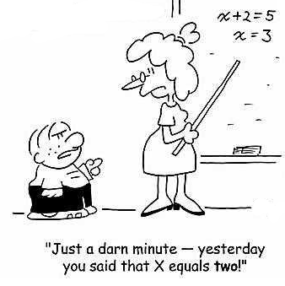
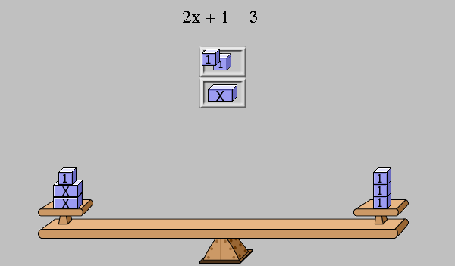

Objective: To demonstrate and communicate an understanding of solving a multi-step equation visually and algebraically.

How to do it:

- Choose a linear equation that requires at least 3 steps to solve for the unknown.
- Represent the equation using a balance scale and algebraically.
- Create a 90-second video communicating how to solve your 3-step algebra problem
- Show the step-by-step solution to the problem using BOTH a balance scale and using algebra.

Rough Draft:

The rough draft will be on the loose-leaf paper and just be a sketch of what your final copy will look like. It must also contain a script for you video explanation for solving your problem! All work should be completed by this date.

Due Date: ________________

Final Copy:

For the good copy an 11 x 14 sheet of paper will be provided. Your video should run through the process of solving the problem both algebraically and using a balance. The video must be a MAXIMUM of 90 seconds long and clearly show how to solve an algebraic problem stepwise. Please take this as an opportunity to be as CREATIVE as possible.

Your video should be posted on YouTube and the URL sent to your teacher before the Due Date!

Due Date: ________________

Solution with a Balanced Scale should include the following:

- A legend provided
- Equation shown using a balance scale
- Equation shown using balance scale after the first step to solving
- Equation shown using balance scale after the second step to solving
- Equation shown using balance scale after the second step to solving (Note: This should be the answer_

Solution solved Algebraically should include the following:

- Full equation
- Steps solved stepwise with the correct answer
- An explanation of each step
- Common mistakes students make when solving algebra problems
- Final answer boxed

Performance-Based Assessment:

Criterion B: Investigating Patterns
Beginning (1-2) | Developing (3-4) | Accomplished (5-6) | Exemplary (7-8)
I am able to:  apply, with teacher support, mathematical problem-solving techniques to discover simple patterns  state predictions consistent with patterns. | I am able to:  apply mathematical problem-solving techniques to discover simple patterns  suggest general rules consistent with findings. | I am able to:  select and apply mathematical problem-solving techniques to discover complex patterns  describe patterns as general rules consistent with findings  verify the validity of these general rules. | I am able to:  select and apply mathematical problem-solving techniques to discover complex patterns  describe patterns as general rules consistent with correct findings  prove, or verify and justify, these general rules.

Criterion C: Communicating
Beginning (1-2) | Developing (3-4) | Accomplished (5-6) | Exemplary (7-8)
I am able to:  use limited mathematical language  use limited forms of mathematical representation to present information  communicate through lines of reasoning that are difficult to interpret.  Few to no titles used  Section unclear  Diagrams unclear  Little to no use of colour  Video is not creative and engaging | I am able to:  use some appropriate mathematical language  use appropriate forms of mathematical representation to present information adequately  communicate through lines of reasoning that are complete  adequately organize information using a logical structure.  Some title missing  Some sections unclear  Diagrams do not standout  Colour used but is not effective in making the connections memorable  Video is somewhat creative and engaging | I am able to:  usually use appropriate mathematical language  usually use appropriate forms of mathematical representation to present information correctly  usually move between different forms of mathematical representation  communicate through lines of reasoning that are complete and coherent  present work that is usually organized using a logical structure.  Most titles included  Section made clear  Diagrams are clear  Colour coding for the components or steps is clear will only minor  Video is both creative and engaging | I am able to:  consistently use appropriate mathematical language  use appropriate forms of mathematical representation to consistently present information correctly  move effectively between different forms of mathematical representation  communicate through lines of reasoning that are complete, coherent and concise  present work that is consistently organized using a logical structure.  Clear titles and sections  Logical flow  Diagrams stand out  The use of colour is effective in making the connections memorable  Video is both extremely creative and extremely engaging

Optional Template – Use Landscape Format

PROBLEM…

Balance Scale Solution | Algebra Solution

