INTRODUCTION

On January 4th, an automobile accident occurred at the intersection of Taylor Way and Marine Dr. in West Vancouver, British Columbia between a compact car (driven by Mr. C. Sandor) and a tractor-trailer (driven by Ms. J. Laursoo). Cases in traffic court revolve around determining who is at fault. As an expert witness, what is your assessment of the claims of the two drivers?

At this intersection, the truck driver had a flashing yellow light while the car driver had a flashing red light. Neither driver claims responsibility for the accident.
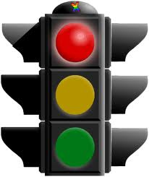
The car driver, Mr. Sandor, claims:
a) to have made a full stop at the light before accelerating and entering the intersection
b) that Ms. Laursoo did not slow down prior to the collision

The truck driver, Ms. Laursoo, claims:
- to have been braking before the collision occured
- that Mr. Sandor did not stop at the flashing red light

YOUR TASK

The court has asked your accident investigation agency to provide a comprehensive analysis of the collision from a physics perspective. Your team (of 2-3 NO MORE) must put together a formal report for the court that assesses the claims of both drivers and determines if one, or both, of the drivers is at fault.

YOUR DELIVERABLES

Your agency is to provide the court with a professional written report that includes:

- Information about British Columbia traffic laws and regulations in question.

- Background information about the physics principles that apply to an automobile collision [forces & motion, work & energy, friction, conservation of momentum, conservation of energy kinematics].

- Detailed calculations that determine:

  - The coefficient of friction between the tires and the road for both the car and the truck.
  - The speed of each vehicle just before the collision
  - The speed of each vehicle just after the collision
  - Determine if the collision was elastic or inelastic (quantitatively)

- A detailed opinion (conclusion) about which driver was at fault (Mr. Sandor or Ms. Laursoo). The opinion must be justified using scientific principles and the detailed calculations that you have provided.
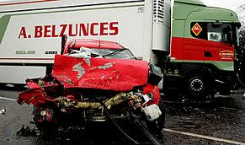
Your agency is to provide to the court verbal testimony summarizing the findings and conclusion of your report. Your testimony must include a visual component that enhances the presentation - poster, PowerPoint, Prezi. Your testimony should be pre-recorded on video. Your testimony should be 3 minutes or less.
CRASH DETAILS

The diagram below provides details about the collision. In addition, the court has provided you the following information from the crash scene investigators:

- The police department determined that the force required to drag a 130 N car tire across the pavement at a constant velocity is 100 N. Specifications from the truck’s manufacturer claim that (for technical reasons) the effective coefficient of friction for truck tires is only 70% that of car tires.

- After collision, the truck and car skidded at the angles shown in the attached diagram. The car skidded a distance of 8.2 m before stopping while the truck skidded 11 m before stopping.

- The weight of the car (driven by Mr. C. Sandor) is 13,600 N and the weight of the truck (driven by Ms. J. Laursoo) is 69,700 N.

- The pre-crash angle between the velocities of the truck and car was 90°.

- The truck driver claims to have begun braking in anticipation of a collision; traveling at only 6.7 m/s at the moment of impact.

- Police measurements show that the distance for the car from the traffic light, located at the front of the intersection, to the collision point was 13.0 m.

- Ford Motor Corporation specifications indicate that the maximum acceleration of a comparably loaded Ford Escort (compact car) is about 3.0 m/s².
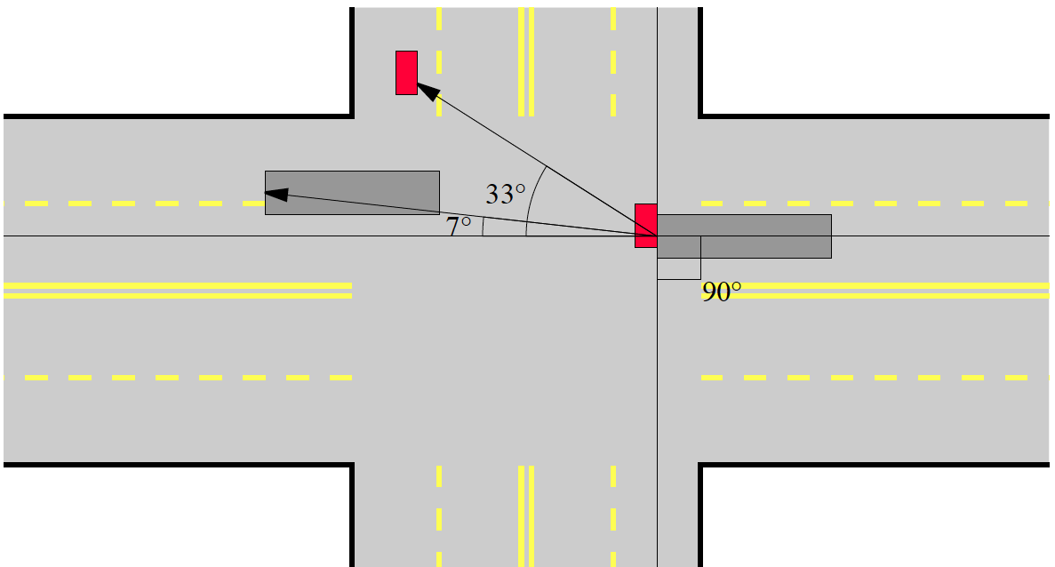

Truck
Car

