Handout - Law of reflection and Snell’s law
By Tian, Sam, Jessica, Oliver and Michael

Law of reflection Lab
Purpose:
To investigate and prove the relationship between angle of incidence and angle of reflection (law of reflection), image distance and object distance, image height and object height.

Hypothesis
The incident angle and the reflective angle should be the same, since we are using a plane mirror. The constant relationship also holds true between image distance and object distance, image height and object height.
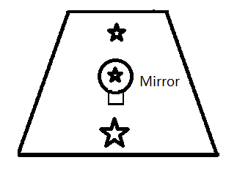
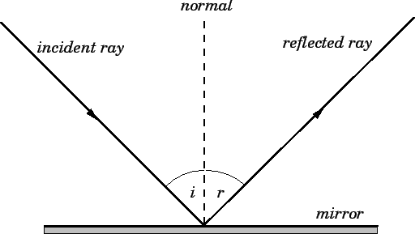

Equipment
Laser pointer Using laser pointer, we can find out the starting and ending point of the
light, which can help us to find out the path taken by the laser.

Protractor Helps us to draw the angle sheet, which helps us to align the laser so we know the incident angle and reflective angle

PC and phone With strong technology, we can analyze the photo taken by phone.

Procedure
Reflection (Laser pointer):
- Set up the mirror; draw the protractor sheet;
- Set the mirror and the protractor sheet perpendicular.
- Use the laser to build the incidence which is coincident with the line of angle 45°.
- Check the laser pointer that is coincident with the vertex of the angle.
- The hypothesis is that the angle of reflection is the same of the angle of incidence. The reflection is coincident with the line of angle 45° (135°) on the opposite side.

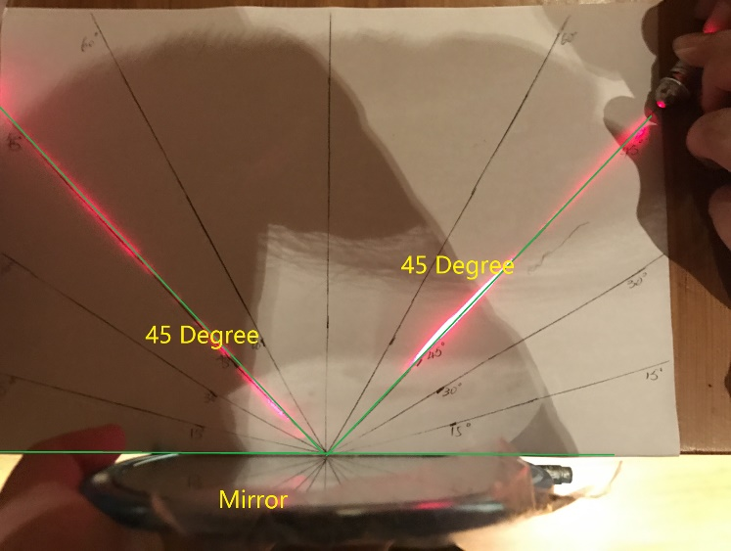
Reflection (Mirror image):
- Set up the mirror in the middle of the table.
- Put one hand on the incidence side. Measure the distance from the hand and the mirror. Take a photo.
- Put the other hand on the reflection side (the other side of the mirror). Get rid of the mirror. With the same posture, take a photo.
- Use the software to compare the reflection and the real hand. The hypothesis is that the image depth and height should be the same.
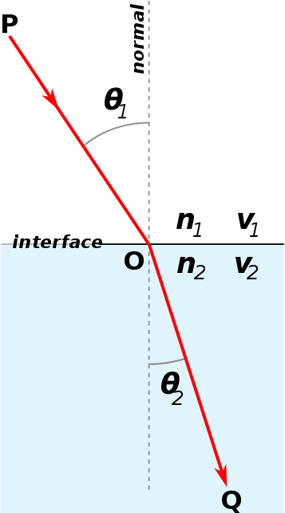
Snell’s Law (Law of Refraction)
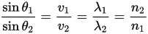
Purpose
The term “refraction” in physics refers to a set of procedures used to identify relationship between angle of incidence and angle of reflection. To determine the unknown, investigators are asked to carry out tests for the refraction angle on the materials separately.

Hypothesis
When a light ray hits another medium, it changes direction. The angle of refraction is smaller than the angle of incidence. Using snell’s law, we can calculate the refractive index of water (1.3), glass (1.5) and plastic (1.5).

Equipment
Laser pointer Using laser pointer, we can find out the start and
end point of the light, which can help us to find out the line and angle.

Ruler Ruler is the point tell us where is ending point if no refraction take place.
So we can find out the difference between

PC and phone With strong technology like logger pro, we can analysis the photos take
by phone.

Water tank Any glass container that has big opening is good.

Glass Thick, large, cubic glass can be a great choice.

Plastic product Thick plastic measuring device will be good.

Procedure
Refraction (Air-plastic Laser point)
- Set up the plastic protractor.
- Put a piece of paper beneath the protractor.
- Use the laser to set an angle of incidence with 30°.
- Take a photo.
- Use the loggerpro. Determine the angle of refraction which is 43.91°.
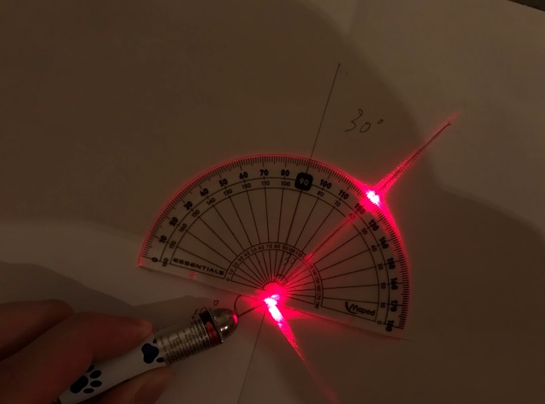
Refraction (Air-water)
- Fill tub with water
- Using protractor measure angles at 0°,10°,20°,30°
- Note down where the laser hits the grid paper in table
- Using the distances noted down on the grid paper and the height of the water to determine angle of refraction
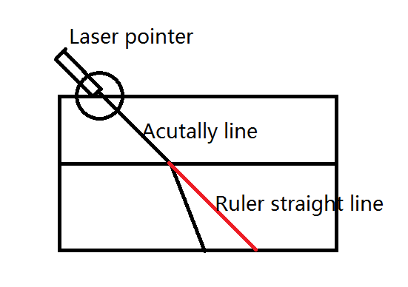
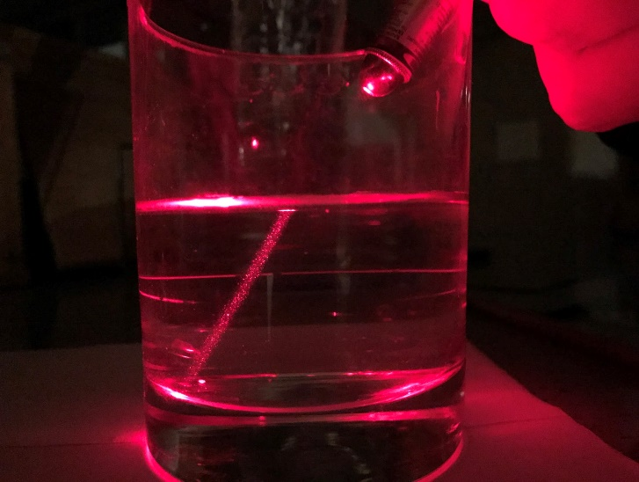
- Using the equation of Snell’s Law to calculate n for water and then average or the n values.
Alternatively, we can take a picture as below and measure the angle on logger pro software.

Rise/Run=85/125=0.68 0.68*-166=-112.88 (Black line ending point)
X=-112.88+89(Blue line ending point)=-23.88
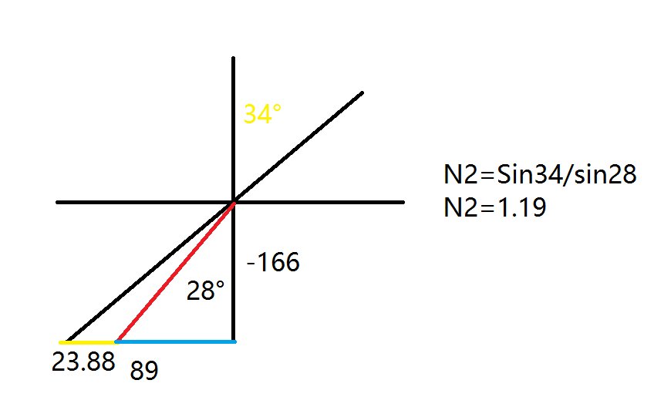
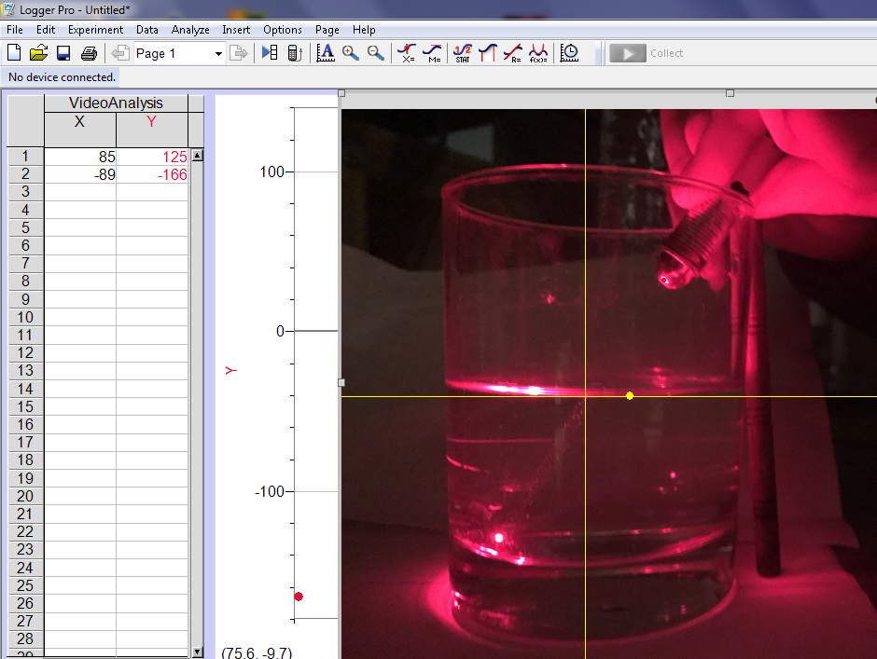

Refraction (Air-glass)
- Use the block of the glass.
- Put a piece of paper underneath the glass block.
- Use the laser to set the incidence point. Use the pencil to plot the incidence point. Draw a line coincident with the incidence line.
- Plot the refraction point. Draw the line coincident with the two-time refraction line.
- Connect the incidence point and the refraction point.
- Take a photo.
- Complete the tracing on the paper to find the angle of incidence and refraction.

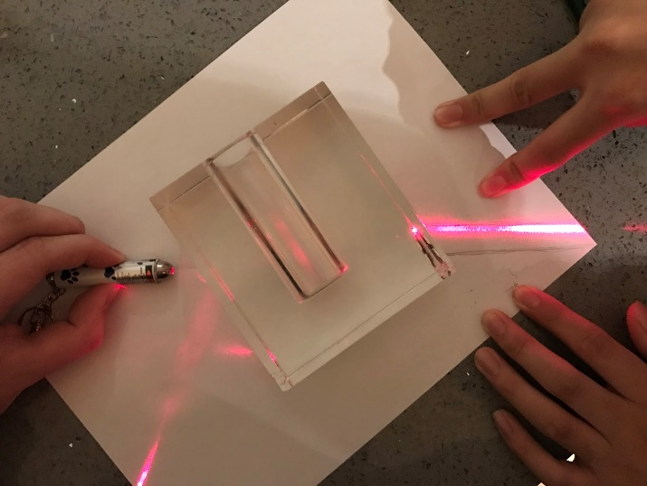

n₁sin(i) = n₂sin(r)
n₂ = sin(i)/sin(r)
n₂ = sin(32 °)/sin(23 °)
n₂ = 1.36

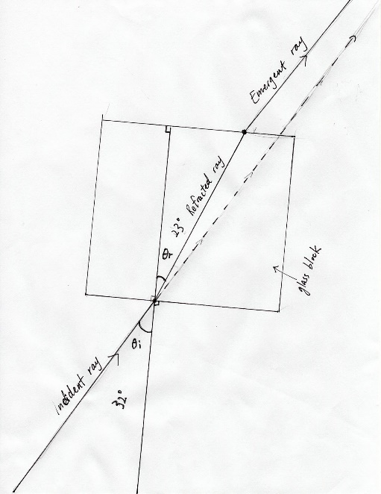

Data
 | Angle of Incidence | Angle of Refraction | Angle of Reflection | Image Height | Image Distance
Reflection (Laser Point) | 45° | - | 45° | - | -
Reflection (Mirror Image) | - | - | - | Same as object height | Same as object distance
Refraction Air-plastic | 44° | 30° | 30° | - | -
Refraction Air-water (Laser Point) | 10°  20°  30° | 9°  14°  21° | - | - | -
Refraction (Air-glass) | 32° | 23° | - | - | -

