Personal Budgets - Worksheet Name: _______________________

- Carlos has made a list of his income and expenses for one month.
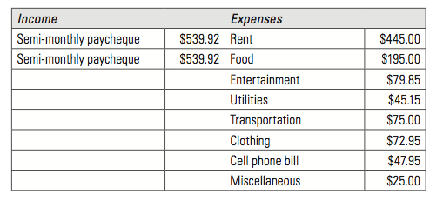
- He plans to put any extra income into a savings account. How much money does he have to put into savings?

- How much money can Carlos save over the course of one year?

- What percentage of his income do Carlos’s savings represent?

- Carlos hopes to buy a new computer in one year. He expects it will cost $1500.00. How much more would he need to save per month to be able to afford it? Suggest one way he could do this.

- Tonia has made a list of her income and expenses for one month. She will put any extra income into savings. If she has an unexpected car repair that costs $243.25, how much will she save this month?
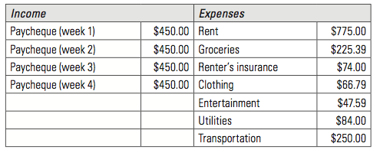

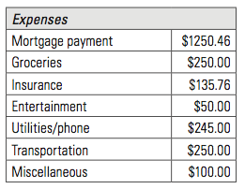
- Franklin earns $2456.85 each month. He expects the following expenses this month:
If he saves the rest, how much can he save in a year? What percentage of his income does this represent?

- Marion has the following monthly income and expenses. She puts any extra income into savings.
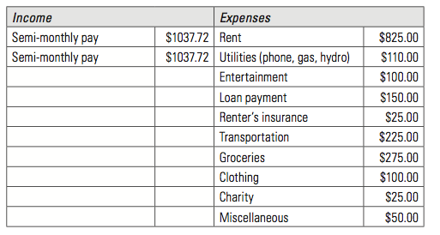
After three months, Marion wants to buy a new TV that costs $1399.99. Will she have enough saved to pay cash?

- Aidan earns $1588.25 per month and has about $1275.00 in expenses per month. If he saves the rest, how many months will it take him to save for a new computer if the one he wants costs $1798.98? (Ignore taxes.)

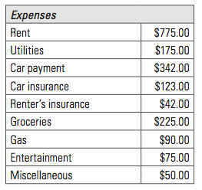
- Karen’s monthly income is $2379.00 and her monthly expenses are as follows.
In January, Karen starts saving for a trip in July that will cost her $3000.00. Will she have enough saved by the beginning of July?

How much more/less will she have in savings?

- Hannah has made a list of her incomes and expenses for one month.
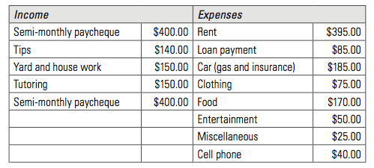
- How much will Hannah be able to save each month? _______________
- What percentage of her income do her savings represent? _______________
- After 6 months, Hannah wants to buy a new bicycle that costs $1199.99. Will she have enough money saved?

- Perseus has regularly saved $125.00 per month since be began working 8 months ago. He has planned a trip in 6 months, which will cost him $1900.00. How much more does he have to save each month to have enough for the trip?

- Shonda has listed her income and expenses for one month. She has regular income from a part-time job, and also earns money from tutoring and babysitting.

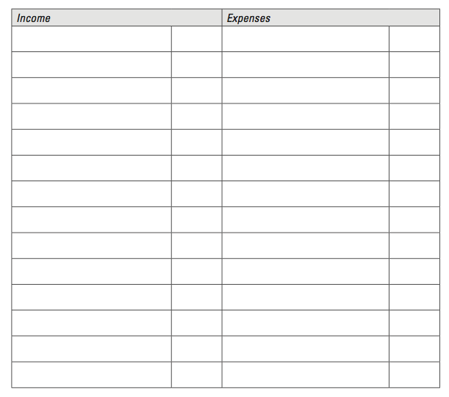
- Sort the items listed into income and expenses.

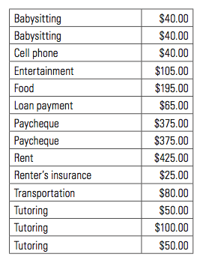

- Calculate her total income and expenses.

- How much can Shonda save in one year? Include any assumptions you made.

- What percentage of her income do her savings represent?

