**Module 5 – Nuclear and Atomic Physics: Quiz 4a**

1. An electron and a proton have the same wavelength. Which of the following statements are correct? ***Include an explanation!***
2. They have the same momentum.
3. They have the same speed.
4. The kinetic energy of the proton is less than that of the electron.

A) I only

B) II only

C) III only

D) I and III only

E) I, II, and III

1. Calculate the wavelength (in meters) of an elephant that weighs 6100 kg and is moving at 11 m/s.



Answers:

1. An electron and a proton have the same wavelength. Which of the following statements are correct?
2. They have the same momentum.
3. They have the same speed.
4. The kinetic energy of the proton is less than that of the electron.

A) I only

B) II only

C) III only

D) I and III only

E) I, II, and III

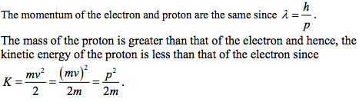

1. 