**Module 5 – Nuclear and Atomic Physics: Quiz 3b**

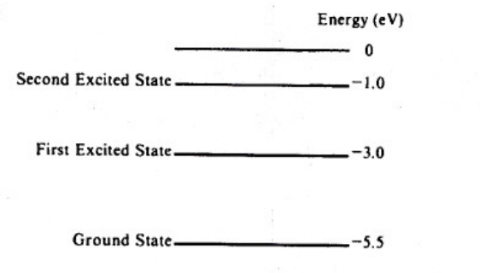

1. A hypothetical atom has two energy levels, as shown above.
2. Determine the frequency of the lowest energy photon that could ionize the atom, initially in it’s ground state.
3. Now, assume the atom has been excited to the state at -1.0 eV. Determine the wavelength of the photon for each possible spontaneous transitions, knowing that the electron will eventual relax to it’s ground state.
4. What will be the speed of each photon emitted when the electron relaxes to a lower state?

Answers:

1. See below:

(a) 

(b) 



(c) Speed of light ☺ 3.0 x108 m/s