**Unit 6 – Nuclear and Atomic Physics: Quiz 3a**

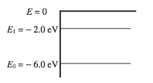

1. What wavelength of light must be absorbed to excite electrons from *E*0 to *E*1?
2. 1240 nm (B) 620 nm (C) 100 nm (D) 210 nm (E) 310 nm

***Use the diagram of a hypothetical atom above for the next TWO questions.***

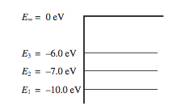

1. If *E*1 is the ground start and *E*2 and *E*3 are the only atomic energy levels available to the electrons, how many lines will be in the emission spectrum of this atom?

(A) zero (B) one (C) two (D) three (E) four

1. An electron in the ground state of the atom depicted above absorbs a photon with an energy of 11 eV. The electron is ejected from the atom. What is the speed of the ejected electron?

Answers:

1. What wavelength of light must be absorbed to excite electrons from *E*0 to *E*1?
2. 1240 nm (B) 620 nm (C) 100 nm (D) 210 nm (E) 310 nm
3.  If *E*1 is the ground start and *E*2 and *E*3 are the only atomic energy levels available to the electrons, how many lines will be in the emission spectrum of this atom?

(A) zero (B) one (C) two (D) three (E) four



1. 